
SCHOOL OF COMPUTING, ENGINEERING AND PHYSICAL SCIENCES

THE ROLE OF ARTIFICIAL INTELLIGENCE IN ENHANCING PREDICTIVE RISK MANAGEMENT IN AGILE IT PROJECTS

STUDENT’S NAME: MANFRED OPPONG
BANNER ID: B01814357

APRIL, 2026

DECLARATION
UWS Assessment Student Declaration
- Declaration that this is your OWN work
All UWS students are expected to uphold the values of academic integrity: UWS Student Academic Integrity Procedure.
Academic Integrity means a commitment to, and upholding of, the values of honesty, trust, fairness, respect, responsibility and courage in learning, teaching, research and engagement with the University community.
You are responsible for ensuring that the work you submit is your own, and that any use of Generative AI follows the guidance provided for the assessment.
I confirm this assessment is my own work and complies with the guidance provided. | YES
- Declaration of appropriate use of Generative AI
You must check the assessment guidance to understand what uses, if any, of Generative AI are permitted for this assessment.
I used Generative AI for this assessment. | NO
If you answered YES, explain briefly what Generative AI tools you used and how you used them:

DEDICATION
I wish to convey my utmost and most heartfelt gratitude to God Almighty, His infinite grace, wisdom and strength which supported me during the difficulties of the work on this project. I also owe a debt of gratitude to my supervisor Durfashan Tariq who gave me thorough advice, helpful recommendations, and unlimited support which proved pivotal in the success of this project. They have indeed played a priceless role in getting this project to come into being.

ABSTRACT
Agile IT projects continue to face delivery challenges such as schedule delays and quality shortfalls even when teams adopt iterative methods. The risk practices in these environments are usually reactive. They are much more dependent on discussions at the regular meetings rather than on defining indicators on the data produced throughout the sprints. This paper investigated how machine learning would help to change the situation by predicting potential risks based on the past performance history. Analysis was done based on open datasets of sprint results and software bugs. Relevant features that were obtained by engineers included velocity fluctuations, backlog pressure, defect trends and delivery variance. They used simple guidelines in categorizing every sprint period as either high risk or low risk. A number of classification models were trained and tested on each other. The best balance was obtained with the Random Forest approach, which had an approximation of 80 percent accuracy and high precision, recall and ROC-AUC. A desktop dashboard was also developed in a more practical manner that would display these predictions in a manner that can be easily used by the project managers. The results suggest that these predictive tools are a good opportunity to transform Agile risk management into more effective action earlier.

TABLE OF CONTENTS

DEDICATION 3
ABSTRACT 4
CHAPTER ONE 6
INTRODUCTION 6
1.1 Context and Background 6
1.2 Motivation and Problem Focus 7
1.3 Aim of the Project 7
1.4 Project Objectives 7
1.5 Project Questions 8
1.6 Overview of the Proposed Solution 8
1.7 Scope and Boundaries of the Project 9
1.8 Significance of the Project 9
1.9 Structure of the Report 10
CHAPTER TWO 12
LITERATURE REVIEW 12
2.1 Introduction 12
2.2 Key Concepts and Definitions Used In This Project 12
2.2.1 Agile Risk Management 12
2.2.2 Predictive Analytics and Machine Learning In Project Environments 12
2.2.3 Explainable AI and Trustworthy Model Use 12
2.2.4 Final Definition of “Risk” Used In This Project 13
2.3 Literature Review Matrix 13
2.4 Synthesis: Patterns, Tensions, and the Research Gap 16
2.5 Chapter summary 17
CHAPTER THREE 19
METHODOLOGY 19
3.1 Introduction 19
3.2 Research Approach and Justification 19
3.3 Data Nature, Sources, and Collection 19
3.4 Operational Definition of “Risk” and Concrete Threshold Values 20
3.5 Data Preprocessing and Feature Preparation 21
3.6 Model development, tools, and explainability 21
3.7 Training strategy, tuning method, and hyperparameter ranges 22
3.8 Evaluation metrics and baseline comparison 22
3.9 Ethical and practical considerations 23
3.10 Chapter summary 23
CHAPTER FOUR 24
IMPLEMENTATION AND TESTING 24
4.1 Overview of the Build Process 24
4.2 Data Acquisition and Reproducibility 24
4.3 Dataset Inspection and Quality Checks 25
4.4 Merging Agile and Defect Sources 26
4.5 Engineering the Proxy Risk Label 26
4.6 Handling Class Imbalance 27
4.7 Model Selection and Training 28
4.8 Live Prediction Function and Fallback Loading 29
4.9 Testing Procedure 29
4.10 Summary of Chapter 4 29
CHAPTER FIVE 30
PRESENTATION OF RESULTS 30
5.1 Model Performance Metrics 30
5.2 Confusion Matrix and Error Structure 30
5.3 Feature Importance 31
5.4 Learning Behaviour and Overfitting 33
5.5 Live Prediction Demonstration 34
5.6 Comparison with Traditional Tracking 35
5.7 Dashboard Workspace View 36
6.1 Achievement Against Objectives 38
6.2 Response to the Research Questions 38
6.3 Practical Significance for Agile Teams 39
6.4 Academic Contribution 40
6.5 Recommendations for Practice 40
6.6 Limitations 41
6.7 Future Work 42
CHAPTER SEVEN 43
CRITICAL SELF-EVALUATION 43
7.1 Overview 43
7.2 Technical Decision-Making 43
7.3 Academic Reasoning 44
7.4 Skills Development 44
7.5 Reflection on Scope and Ambition 45
APPENDICES 50
COPY OF PROJECT SPECIFICATION 57

Figure 1: Load Data tab showing automated ZIP extraction and dataset registration 27
Figure 2: Data Preview tab used for schema validation of the Agile Projects Dataset 28
Figure 3: Feature Engineering tab documenting the eleven proxy features and the pipeline output 29
Figure 4: Train Model tab with the four selected algorithms and the training log 30
Figure 5: Evaluation tab showing the final metrics table for all four classifiers 32
Figure 6: Pearson correlation heatmap for the CM1 NASA defect dataset 34
Figure 7: Pearson correlation heatmap for the Agile Projects synthetic dataset 35
Figure 8: Learning curves showing training and validation log loss for two classifiers 36
Figure 9: Risk Predictor tab showing a live low-risk prediction with gauge visualisation 37
Figure 10: Team turnover rate by predicted risk level 38
Figure 11: Dashboard tab summarising the active workspace 39

CHAPTER ONE

INTRODUCTION

1.1 Context and Background
Agile practices are popular in the delivery of software and IT projects due to the ability to promote iterative development, rapid feedback, and responsiveness to the changing needs (Schwaber and Sutherland, 2020; Highsmith, 2019). Practically, however, quite a number of Agile IT projects continue to suffer delivery issues like schedule slippage, cost pressure, fluctuating scopes and quality defects. The evidence in the industry still indicates that the IT projects fail to deliver the expectations in terms of time, cost, and scope even in the situations when the modern development methods are involved (Standish Group, 2020).
One of the challenges is connected to the risk management in Agile settings. Risk management is often formalised in plan-based approaches with organised processes of identification and analysis, response planning, and monitoring (PMI, 2021). In contrast, agile teams tend to resolve risks in informal and embedded protocols in sprint planning, daily stand-ups, reviews, and retrospectives. Such practices may be conducive to continuous learning, but can also be reactive, and risks are only given attention once they start to impact the performance of sprints or delivery results (Conforto et al., 2016). This can reduce predictive visibility and in cases where projects are run under unpredictable circumstances where early warning indicators are vital.
Meanwhile, Agile creates rich operational information in artefacts and tools (e.g., backlogs, sprint records, issue logs, defect reports, velocity history). Such data opens possibilities of more predictive and evidence-based risk management strategies. Artificial Intelligence (AI), specifically machine learning, has proved useful in project and software analytics activities including defect prediction and effort estimation, where the models are trained on prior data to make forecasts that can be used to make decisions (Wang, Li, Wang and Chen, 2021). The expanded field of project management scholarship also begins to view AI as a potential that may empower the work of managers in case it is deployed as a decision-support tool, but not as an automation tool (Marnewick, 2022; Raisch and Krakowski, 2021).

1.2 Motivation and Problem Focus
Despite the fact that numerous Agile teams monitor performance metrics like velocity, burn-down deviations, defect trends and backlog growth, these metrics are typically interpreted intuitively and in a retrospective manner. Consequently, risk management might be reactive as opposed to predictive and have less capacity to foresee the occurrence of a risk earlier to intervene in time (Conforto et al., 2016).
At the same time, formal risk models suggest the systematic risk analysis but Agile teams may feel that these methods are too documentation-intensive or that they do not fit well into the short delivery cycles (PMI, 2021). This introduces a viable disruption: Agile projects require risk insight early in the project that is practical to fit the iterative delivery, and not processes that slow teams down or processes relying solely on subjective estimation.
Predictive analytics based on AI can be used to address this gap by utilizing the data on sprints and deliveries to determine patterns that can be related to the emergence of risky conditions. But although the predictive dashboards and alerts are now becoming commercialized, there is a dearth of empirical evidence, based on structured project data, on whether the AI-inspired predictive methods can indeed enhance risk foretelling in Agile IT settings. The current project addresses this need by designing and testing a prototype predictive risk artefact on Agile datasets that are publicly available.

1.3 Aim of the Project
The aim of this project is:
To assess how predictive techniques based on Artificial Intelligence can be effective in improving risk management in Agile IT projects.

1.4 Project Objectives
The objectives that guide the work in order to reach the project aim are as follows:
- To develop a critical literature review of the literature on Agile risk management, predictive analytics and machine learning application in project settings.
- To detect, pre-process and organise publicly available Agile project data which can be used in predictive modelling.
- To develop and deploy a predictive risk model that relies on machine learning and applies to the use of the appropriate sprint and performance measures.
- To measure how the developed model performs in prediction based on established classification measures.
- To compare the AI-based predictive results with the conventional Agile performance tracking indicators.
- To come up with relevant recommendations to adopt AI-based predictive risk systems into Agile IT project governance.

1.5 Project Questions
- RQ1: What does recent research say about Agile risk management and how machine learning is used for predictive risk analysis in project environments?
- RQ2: Which publicly available Agile project datasets are suitable for predictive modelling, and how much usable data remains after cleaning and preprocessing?
- RQ3: Can a machine-learning model be built using sprint and performance metrics (e.g., velocity, defect levels, backlog growth, schedule variance) to predict project risk, and which metrics are the strongest predictors?
- RQ4: How well does the developed model predict project risk on unseen data, based on accuracy, precision, recall, F1-score, and ROC-AUC?
- RQ5: Does the AI-based model detect risks better than traditional Agile tracking indicators (e.g., velocity trends and defect trend checks), in terms of fewer false alerts and missed risks?
- RQ6: Based on the results, what practical steps can Agile teams take to integrate AI-based predictive risk tools into their project governance and decision-making?

1.6 Overview of the Proposed Solution
This project develops a prototype on predictive risk analysis on AI with the help of machine learning classification methods. The prototype will produce risk likelihood results on the basis of sprint and performance metrics which include velocity trends, defect density, backlog growth and schedule variance. It is a quantitative and experimental method: Agile datasets of historical data are trained and tested on models and the performance of these models is measured with traditional classification measures including accuracy, precision, recall, F1-score, and ROC-AUC (Wang, Li, Wang and Chen, 2021).
By aligning with the automation-augmentation view, the project will establish AI as a decision-support tool that is supposed to enhance risk awareness and governance, but not to take the place of human judgement (Raisch and Krakowski, 2021). The value that should be achieved is to identify the risk patterns earlier in such a way that the project teams can respond promptly and better.

1.7 Scope and Boundaries of the Project
The project is planned as a single MSc dissertation, has been scoped as feasible, rigorous and replicable.
Scope of work
The aim of the project is to design, implement and test a predictive machine learning artefact to forecasting risk in Agile IT projects based on sprint and performance measures.
Data scope
Only publicly available sources of Agile projects (e.g., open repositories and research datasets) are used as secondary data in the study. No direct data gathering with human subjects is taken.
Evaluation scope
This is assessed on model performance measures that are usually employed in classification. The project focuses more on empirical evaluation of predictive power as opposed to organisational change management results.
Delimitations
The project is not an interview, survey and field study of the practitioner adoption or perceptions. It also fails to purport to offer a thorough framework of organisational risk, rather it offers a prototype artefact and demonstration of predictive performance together with recommendations based on results and literature.

1.8 Significance of the Project
This project is significant in two main ways.
Practical significance
Agile delivery relies on making decisions at the right time when there is uncertainty. When AI-based predictive methods are able to offer plausible early warnings, they can assist in improved risk monitoring and intervention prior to the development of risks into delays, re-work, and substandard quality. This assistance is particularly helpful when AI is applied as an extension of the managerial judgement but not to make the decisions (Raisch and Krakowski, 2021).
Academic significance
The studies of AI in the project setting usually concentrate either on technical accuracy of single tasks or extensively on conceptual models. Empirical, data-driven analysis assessing predictive assertions against actual project pointers is required. The project provides evidence on whether AI can play a significant role in predictive risk management in Agile IT projects by creating and testing an artefact based on predictive risk management and using quantifiable Agile performance metrics for prediction (Wang, Conboy and Cawley, 2021).

1.9 Structure of the Report
This report follows the recommended structure for an individual MSc project:
- Chapter One (Introduction) describes the project context, motivation, aim, objectives, scope, significance and report structure.
- Chapter Two (Literature Review) critically analyzes the Agile risk management and predictive analytics, AI/machine learning in a project environment, and decision-support perspectives and suggests gaps that are filled by the project.
- Chapter Three (Research Design) describes and reasons the methodology, data sources, preprocessing strategy, modelling decision, evaluation plan and ethical considerations.
- Chapter Four (Implementation & Testing) outlines the implementation, feature engineering, model training procedures, and implementation choices that went into the building of the predictive artefact. It also reports testing processes and evaluation results against regulatory measures and standards.
- Chapter Five (Presentation of Results) is well presented with findings that are presented clearly with tables/figures where necessary and what the results imply to the Agile risk management.
- Chapter Six (Conclusions & Recommendations) summarises the achievements against the aim/objectives, elaborates on the significance, identifies limitations and gives a future work suggestion.

CHAPTER TWO

LITERATURE REVIEW

2.1 Introduction
The chapter is a synthesis of studies on (1) Agile risk management, (2) predictive analytics and machine learning in the project/software setting, (3) explainable AI (XAI) and model governance to use AI responsibly, and (4) hybrid risk frameworks and how to integrate Agile delivery with formal controls. The reason is to determine what is well-known, where the evidence is weak, and how these gaps warrant this project artefact: an AI-based predictive risk model that has been trained on Agile sprint and performance data and is measured using standard classification measures (Schwaber and Sutherland, 2020; Conforto et al., 2016; PMI, 2021; Raisch and Krak, 2021; Wang, Li, Wang and Chen, 2021).

2.2 Key Concepts and Definitions Used In This Project

2.2.1 Agile Risk Management
The agile risk management is also often integrated into sprint planning, daily meetings, review, and retrospectives, instead of being taken care of with the help of formal risk registers and comprehensive documentation (Conforto et al., 2016; Schwaber and Sutherland, 2020). This facilitates acceleration and teamwork at the expense of systematic prediction and early warning as compared to the more traditional risk governance methods (PMI, 2021).

2.2.2 Predictive Analytics and Machine Learning In Project Environments
Machine learning is able to learn the patterns based on the past project and software data and predict the results (defects, effort, and issues with delivery) (Wang, Li, Wang and Chen, 2021). These methods apply to Agile situations since Agile instruments produce regular data about operations (e.g., issue flow, backlog change, delivery variance) that can be modeled to create early-warning indicators (Wang, Conboy and Cawley, 2021).

2.2.3 Explainable AI and Trustworthy Model Use
With more complicated machine learning models, the concept of explainability is relevant to trust, accountability, and effective decision-making. Explainable AI techniques seek to provide information on which aspects contribute to a prediction and why they do, allowing stakeholders to interpret and dispute outputs. One of the most popular methods is SHAP that offers explanations of features given by Shapley values (Lundberg and Lee, 2017). On a governance scale, the NIST AI Risk Management Framework emphasizes the use of practical controls in dealing with AI risks, such as transparency, accountability, and continuous monitoring of systems deployed (NIST, 2023).

2.2.4 Final Definition of “Risk” Used In This Project
Because there is often no explicit label of risk in public Agile datasets, this project defines predictive risk as a binary state of risk, based on observable sprint and performance indicators (i.e., proxy-based labelling). A sprint (or sprint window) is considered to be of High Risk in case it displays one or more early-warning conditions, including:
- Velocity instability (e.g., unusually large deviation from recent sprint velocity trend)
- Defect pressure (e.g., spike in defect density or defect inflow/outflow imbalance)
- Backlog growth pressure (e.g., backlog growth rate rising beyond a defined threshold)
- Delivery variance (e.g., schedule variance / missed sprint commitments)
Any other cases will be labeled as Low Risk. This working definition fits with the practical way Agile teams monitor the emergent delivery issues with metrics and trends (Conforto et al., 2016; Schwaber and Sutherland, 2020) and does not conflict with the data-driven modelling and assessment.

2.3 Literature Review Matrix
The following table is designed to demonstrate: (a) the statements made in the literature, (b) where it is insufficient, and (c) how the gap drives your final modelling decisions: Logistic Regression (baseline), Random Forest (non-linear ensemble), and XGBoost (gradient boosting), evaluated as a binary classification performance based on accuracy, precision, recall, F1-score, and ROC-AUC.
FOCUS AREA | WHAT THE LITERATURE GENERALLY SHOWS | MAIN GAPS / LIMITATIONS | LINK TO THIS PROJECT (RISK DEFINITION + MODEL CHOICES)
Agile methods and lightweight governance | Agile (e.g., Scrum) is focused on responsiveness through iterative delivery and feedback, and lightweight governance (which may be frequently seen) (Schwaber and Sutherland, 2020; Highsmith, 2019). | Agile guidance is robust and has high cadence, but lacks systematic predictive risk-related mechanisms beyond inspection and adaptation. | Rationalizes the inclusion of a predictive layer, which models sprint cycles: risk signals based on sprint metrics, and not heavy documentation.
Risk management practice in Agile | Risk management is commonly incorporated into ceremonies and communication among a team; it fosters transparency though may be reactive (Conforto et al., 2016). | Numerous works present practices, but fail to operationalise quantifiable early-warning risk detection with actual sprint data. | Supports the notion of risk as a binary condition based on quantifiable indicators (velocity instability, defect pressure, growing backlog, delivery variance).
Traditional risk frameworks vs Agile tension | Standards prescribe a systematic risk identification, analysis and monitoring, enhanced governance (PMI, 2021). | The conventional ones might be considered to be documentation-focused and incompatible with Agile speed which restricts its integration into sprints. | Places the model as a lightweight predictive governance: automated signals which are not substitutions of Agile routines.
Hybrid risk frameworks and mixed governance | There is recent research indicating that organisations are adopting more hybrid forms of Agile practices and structured controls (hybrid approaches) to cope with complexity and quality (Mirzaei et al., 2025).). | Hybrid work does not have well-defined data-based escalation parameters and regular analytics implementation into the governance processes. | Endorses the development of recommendations that are compatible with hybrid governance, and compares the results of ML with realistic rule-based indicators.
Risk prediction evidence in software/IT contexts | Systematic reviews indicate that the use of data-driven approaches to software and project risk prediction and early warning is on the rise (Mahmud et al., 2022). | Evidence are scattered throughout datasets and definitions; the term ‘risk’ is inconsistently coded, so it is less comparable and replicable. | In favor of open-ended proxy labelling and multi-metric assessment (precision/recall/F1/ROC-AUC) rather than the accuracy per se..
AI explainability and trust for adoption | Explainability algorithms enable making the model outputs auditable and actionable. SHAP offers a single method of feature attribution of complex models (Lundberg and Lee, 2017). | Most predictive studies focus on accuracy, but do not demonstrate how explanations can be used to make decisions or governance. | Encourages the explanation outputs (coefficients, feature importance, SHAP-style explanations) to enable risk alerts to be read and taken.
Explainable AI in project risk management (recent) | Recent efforts put forward explainable AI systems in project risk management to enhance risk prediction interpretability (Badhon et al., 2025). | These frameworks are not necessarily assessed using publicly reproducible Agile datasets or compared to plain operational baselines. | Enhances the contribution of the project: reproducible assessment on publicly available Agile data, comparison of benchmarks, and explanations.
Why Logistic Regression as baseline | Logistic Regression is popular as a baseline due to its simplicity, efficiency and interpretability (Wang, Li, Wang and Chen, 2021). | The non-linear interactions in delivery dynamics may be missed by the linear assumptions. | Establishes a clear standard and is conducive to explanation by the use of coefficients; less efficient performance warrants more complicated models.
Why Random Forest | Random Forest is used to obtain non-linear relationships and interactions, as well as measures of feature importance (Wang, Li, Wang and Chen, 2021). | It is not as transparent as simple models and can overfit without tuning. | Helps model complicated dynamics (e.g., growth of the backlog and defect pressure) and promote interpretability through importance.
Why XGBoost | Gradient boosting algorithms tend to perform well with structured tabular data, and have the ability to capture complex non-linear trends (Wang, Li, Wang and Chen, 2021). | They are tunable, and can be explained as a black box. . | Being on the list of high-performing candidates; will be accompanied by explainability (e.g., SHAP) to enhance trust and governance.
Traditional Agile tracking vs predictive modelling | Agile teams usually track their delivery through such indicators as velocity trend, burndown deviations, defect trends, and backlog changes (Schwaber and Sutherland, 2020). | Past tracking tends to be hindsight and seldom measures false alarms and missed risks. | Encourages a relative standard: ML predictions vs indicator alerts based on rules, assessed in terms of precision/recall and false-alerts.

2.4 Synthesis: Patterns, Tensions, and the Research Gap
There are three patterns that can be found all over the literature. To start with, Agile practices are based on transparency and iterative feedback, which may result in more reactive than predictive risk management when early warnings are primarily based on manual interpretation (Conforto et al., 2016; Schwaber and Sutherland, 2020). Second, traditional standards have structured risk governance, which might be incompatible with Agile speed of delivery and lightweight documentation (PMI, 2021). Third, despite machine learning being able to generate predictive indicators out of project and software data, the predictive indicators are not useful in real governance without explainability and reliable execution since models may turn into black-box dashboards without actionable results by teams (Lundberg and Lee, 2017; NIST, 2023; Raisch and Krakowski, 2021).
The resulting tensions give rise to the design of this project: a quantifiable proxy definition of Agile delivery risk, a comparison of models with Logistic Regression, Random Forest and XGBoost, and explainability results (coefficients/importance/SHAP-style explanations) to help build trust and actionability. The literature of hybrid governance reinforces the pragmatics of the artefact and acknowledges that a large number of organisations focus on Agile and structured controls and thus require predictive tools that can be seamlessly incorporated into governance practices (Mirzaei et al., 2025).
The resulting gap is the source of the design decisions of the given project: a binary definition of predictive risk relying on the quantifiable Agile sprint indicators, and a comparison of Logistic Regression, Random Forest, and XGBoost to the traditional Agile tracking guidelines, through the use of established classification metrics.

2.5 Chapter summary
The chapter laid the academic groundwork of predictive risk management based on AI in Agile IT projects. It pointed out the constraints of reactive Agile risk activities, the conflict between lightweight delivery and formal risk management, and the necessity of explainable and reliable AI deliverables to adopt. It also supported the operational definition of risk and the choice of Logistic Regression, Random Forest and XGBoost to conduct a comparative analysis. The following chapter describes the pipeline of methodology and evaluation.

CHAPTER THREE

METHODOLOGY

3.1 Introduction
This chapter supports and explains the methodology of achieving the objective of the project: to determine whether AI-based predictive models can enhance risk management in Agile-based IT projects. It is based on the approved plan: a quantitative, experimental artefact-development design, in which secondary/public agile project datasets are used, and the predictive performance is measured using well-known classification metrics (Saunders, Lewis and Thornhill, 2019; Wang, Li, Wang and Chen, 2021).

3.2 Research Approach and Justification
The quantitative experimental design is appropriate since the project will be testing measurable relationships between sprint/performance indicators and an operational risk outcome based on machine learning, as opposed to gathering perceptions of the participants (Saunders, Lewis and Thornhill, 2019). This method enables a fair comparison of different models and enables clear reporting of predictive performance on unknown data through common metrics (Wang, Li, Wang and Chen, 2021). It is also in line with the modern concept that AI has to be empirically tested and applied to aid in making decisions in a management setting (Raisch and Krakowski, 2021).

3.3 Data Nature, Sources, and Collection
The research employs secondary data on freely available repositories and research data. The project will employ one or more of the following datasets (based on the availability of features after inspection and cleaning up):
- Apache Jira Issue Tracking Dataset (Zenodo record): issue-level data for Apache Software Foundation projects: https://zenodo.org/records/5665896 (Zenodo, 2021).
- The Public Jira Dataset (Zenodo; 16 public Jira repositories, 2.7M issues): https://zenodo.org/records/15719919 (Zenodo, 2025).
- The JIRA Repository Dataset (ACM): large-scale JIRA issue data across multiple open source ecosystems (Ortu et al., 2015).
- GHTorrent: structured snapshots of GitHub repositories, issues, pull requests and metadata: https://github.com/ghtorrent/ghtorrent.org/blob/master/faq.md (GHTorrent, n.d.).
- GH Archive: public GitHub event stream archives for longitudinal activity and issue/PR events: https://www.gharchive.org/ (GH Archive, n.d.).
These data sets give the history of issues, timestamps, labels/types, status changes, and activity traces based on which sprint-like windows and delivery indicators are possible to extract. In case a direct Jira sprint fields are present (e.g., explicit sprint IDs), then they will be used. Otherwise, the analysis will assume a uniform time-window method to match Scrum cadence (14-day rolling windows) to estimate the sprint duration (Schwaber and Sutherland, 2020).

3.4 Operational Definition of “Risk” and Concrete Threshold Values
A direct label on risk is not present in most of the public Agile datasets. In order to facilitate modelling, this project defines risk as a binary condition based on quantifiable early-warning conditions in sprint and performance measures (proxy-based labelling). Every sprint (or 14-day window) is marked High Risk (1) in case the following four conditions are satisfied: TWO or more of the following four conditions are satisfied: This two-out-of-four principle minimizes the risk of a single noisy metric being used to issue a risk label and corresponds to the concept that risk is typically multi-factorial in reality (Conforto et al., 2016).
- Condition A (Velocity instability): completed work 3- or more sprints/windows equals or less than the rolling mean of the past 3 sprints/windows, OR coefficient of variation of velocity over preceding 4 windows equals or greater than 0.25.
- Condition B (Defect pressure): The defect density (defect-type issues/total issues) is in the upper 20 percent of the project, OR defect density improves by 30 percent or more in comparison to the prior window.
- Condition C (Backlog growth pressure): an increase in the size of the backlog (open issues) by 10 percent or more in the window, OR the growth rate of the backlog is in the top 20 percent in the project.
- Condition D (Delivery variance): committed work shortfall = 15% (committed work shortfall divided by committed work). In the absence of commitment, commitment is estimated by the items that get transferred into the To Do/In Progress at the time of windows openings.
These are deliberately low and straightforward to understand in order to replicate the labelling. In the analysis process, there will be a short sensitivity test (e.g., within 5 percentage points on the core cut-offs) to ensure that the results are not pushed by a single arbitrary point of setting a threshold (Saunders, Lewis and Thornhill, 2019).

3.5 Data Preprocessing and Feature Preparation
Public project data may not be complete and may be inaccurate; thus, preprocessing is necessary prior to training. Steps include:
- First, data cleaning eliminates duplicates, formats and irrelevant fields.
- Second, record deletion or simple imputation (median of skewed numeric variable) is used to fill in missing values depending on the level and nature of missingness.
- Third, numerical characteristics are normalised where necessary (mostly in Logistic Regression).
- Fourth, feature engineering develops variables that reflect accumulation of risk over time, e.g., moving averages, week-on-week variation, backlog increase percentage, and inflow/outflow balance of defects.
- Fifth, feature selection removes noise and selects the most informative predictors based on correlation checks and model-based importance (Wang, Li, Wang and Chen, 2021).
- Finally, the data is divided into test and training sets (80/20), stratification is performed where possible and, therefore, the generalisation is tested on the unseen data (Saunders, Lewis and Thornhill, 2019).

3.6 Model development, tools, and explainability
The predictive artefact is written in Python based on pandas / NumPy to work with data and scikit-learn to model and evaluate it. Three classifiers are used to strike a balance between interpretability and predictive power: Logistic Regression (base), Random Forest and XGBoost (gradient boosting). Logistic Regression provides a transparent benchmark and interpretable coefficients. Random Forest recaptures non-linear relationships and interactions and gives feature importance. XGBoost is added since boosted trees can be very effective on structured tabular data and can learn complicated patterns that would be overlooked by simpler algorithms (Wang, Li, Wang and Chen, 2021).
To enhance the usefulness and trust in the study, explainability outputs will be reported. The Odds ratios and coefficients will be used to interpret the Logistic Regression. Random Forest will be based on permutation importance. In the case of XGBoost, the creation of feature attribution will be generated through SHAP-style explanations in cases where possible (Lundberg and Lee, 2017). Explainability is discussed as an aspect of model governance, in line with risk management principles which focus on transparency and monitoring to use AI in a trustworthy way (NIST, 2023).

3.7 Training strategy, tuning method, and hyperparameter ranges
A training set is used to train the models by using k-fold cross-validation and subsequently tested on a held-out test set. The RandomizedSearchCV (50 iterations) will be used to perform Hyperparameter tuning with 5-fold cross-validation. The use of randomized search is due to its efficiency and ability to cover larger parameter spaces within the MSc time limitation (Wang, Li, Wang and Chen, 2021). In the cases, in which the parameter grid is small, GridSearchCV can be employed.
- Logistic Regression (scikit-learn): C ∈ {0.01, 0.1, 1, 10, 100}; penalty = {l2}; solver = {liblinear, lbfgs}; max_iter = {500, 1000}; class_weight = {None, balanced}.
- Random Forest: n_estimators ∈ {200, 500, 1000}; max_depth ∈ {None, 10, 20, 40}; min_samples_split ∈ {2, 5, 10}; min_samples_leaf ∈ {1, 2, 4}; max_features ∈ {sqrt, log2, 0.5}; bootstrap = {True}; class_weight = {None, balanced}.
- XGBoost: n_estimators ∈ {200, 500, 800}; max_depth ∈ {3, 5, 7, 10}; learning_rate ∈ {0.01, 0.05, 0.1, 0.2}; subsample ∈ {0.6, 0.8, 1.0}; colsample_bytree ∈ {0.6, 0.8, 1.0}; reg_lambda ∈ {1, 5, 10}; min_child_weight ∈ {1, 5, 10}.
The ROC-AUC and F1-score is the top priorities in model selection to capture the early-warning performance in the case of possible class imbalance (Wang, Li, Wang and Chen, 2021). When there are few cases of High Risk, then the scale of imbalance between the classes will be managed through class weights (Logistic Regression/Random Forest) and scale pos weight (XGBoost) and the findings will be displayed with precision trade-offs/recall.

3.8 Evaluation metrics and baseline comparison
The evaluation of performance is based on accuracy, precision, recall, F1-score and ROC-AUC (Wang, Li, Wang and Chen, 2021). Precision and recall are highlighted since predictive risk systems have to strike a balance between false alarms and missed risks. The baseline on the rule-based comparison against AI outputs between traditional Agile tracking is implemented with the same threshold indicators as those used in labelling (e.g., velocity drop ≥20%, defect spike ≥30%, backlog growth ≥10%, delivery variance ≥15%). This baseline is compared to the ML models with the same metrics, which allows making a direct comparison with traditional performance tracking practices (Schwaber and Sutherland, 2020).

3.9 Ethical and practical considerations
The risk of ethics is low since the research is on publicly available data and there is no participants, consent or sensitive data collection. Analysis concentrates on project level indicators and does not use unwarranted personal information. Considerations related to governance are responsible use of models, transparency, and monitoring, which are in line with AI risk management guidance (NIST, 2023). The practical constraints are variations in the recording of sprints/defects of the project, the absence of fields in the datasets, and the validity of the risk labels of the proxy. They are handled using transparent assumptions, uniform preprocessing, strong validation and explicit reporting of limitations (Saunders, Lewis and Thornhill, 2019).

3.10 Chapter summary
In general, the approach focuses on reproducibility by ensuring that the code used is documented, that there are rules governing fixed labelling and that the evaluation procedures are stable. The chapter proposed a viable approach to an individual MSc project: the choice of named open data, the use of concrete threshold-dependent proxy labelling of risk, the training and tuning of Logistic Regression, the use of Random Forest and XGBoost models, the use of explainability outputs, the assessment of these models against standard metrics and an indicator baseline.

CHAPTER FOUR

IMPLEMENTATION AND TESTING

4.1 Overview of the Build Process
The development of AgileRisk AI followed a series of well-defined steps starting with the raw data extraction to a working desktop prototype. All of the stages were coded within the Jupyter notebook and then appeared as the Tkinter graphical interface to allow the project managers, who were not technical, to utilize the system without dealing with code. The notebook is used in a linear sequence of loading, cleaning, engineering, training, evaluating and deploying, and aligns with the pipeline architecture that Amershi et al. (2024) suggest to use to conduct machine learning research in a reproducible manner. This multi-layered design also maintains the separation of concerns talked about in Chapter 3 where each layer should be testable and only then should they be integrated with the interface.

4.2 Data Acquisition and Reproducibility
The automated data acquisition was a Python program based on the zipfile and shutil packages, which is a routine ZIP-based extraction program. The routine reads a directory selected by the user, unpacks all the archives to a temporary workspace and catalogs the extracted CSV and XLSX files in memory. This design is important in that Agile research data are normally provided in the form of compressed bundles (as in the TAWOS repository), and manually decompressing them will add silent versioning bugs. The Load Data tab in Figure 1 attests that 19 datasets totalling 30,160 records were loaded in one session, featuring the four TAWOS sprint corpora (Mesos, Spring XD, Aurora, Usergrid), five NASA PROMISE defect tables (CM1, PC1, JM1, KC1, KC2), and a synthetic agile project tracker. This step will be automated to safeguard the principle of reproducibility highlighted by the FAIR data movement (Wilkinson et al., 2023) and to ensure that any replication of the study in the future will have the same inputs. To enhance reproducibility, all random seeds were set to 42 in numpy, scikit-learn and joblib, so that a researcher who re-runs the notebook with the same inputs will get bit-identical splits, rankings of importance and serialised model weights
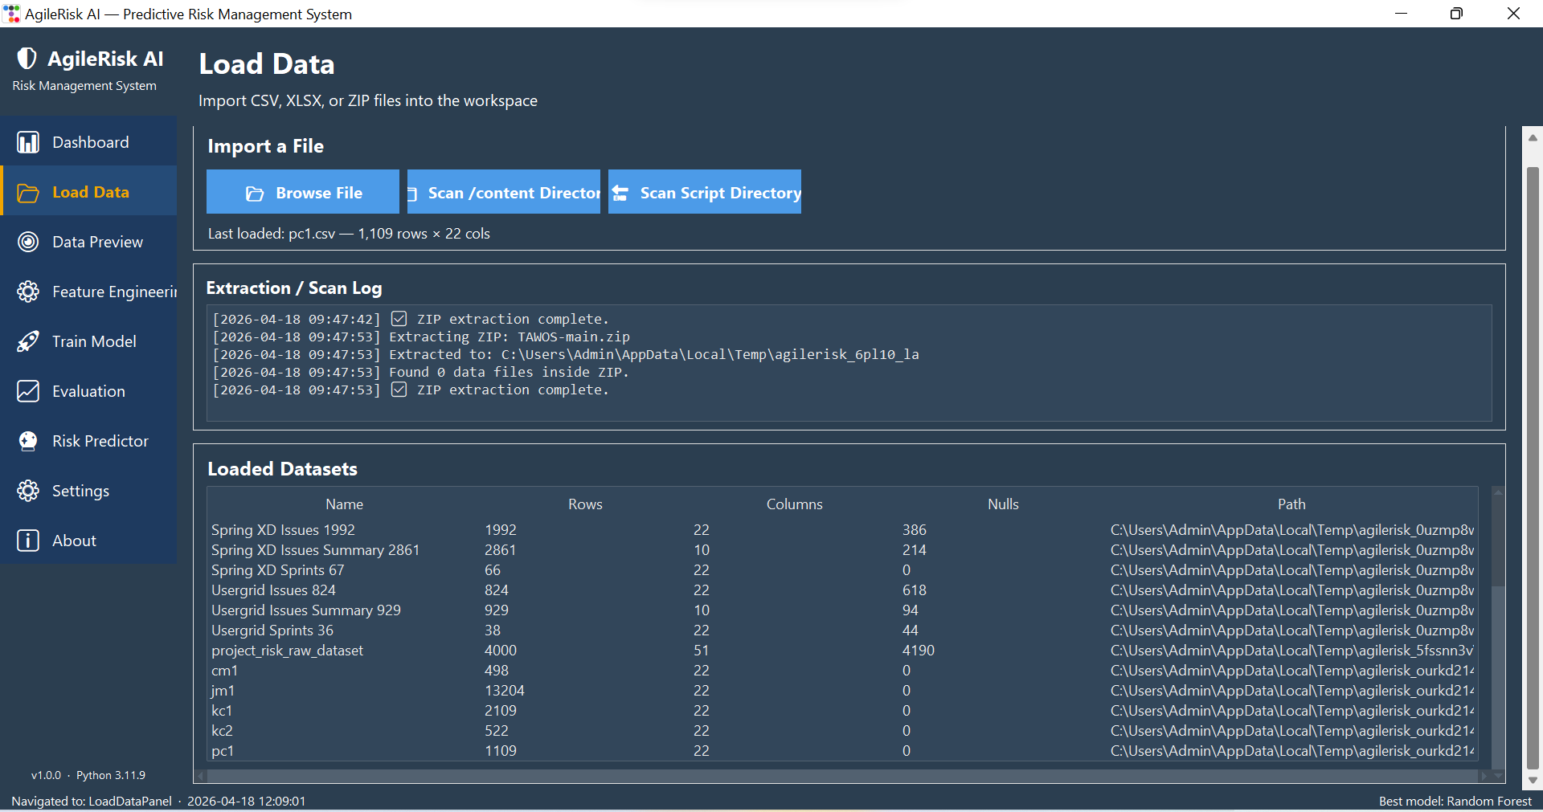
Figure 1: Load Data tab showing automated ZIP extraction and dataset registration

4.3 Dataset Inspection and Quality Checks
All loaded datasets were previewed in the Data Preview tab that could be seen before any feature construction in Figure 2. The preview shows the row count, column count, the null count and the first 20 rows and thus enabled easy identification of anomalies e.g. the number of nulls (4,190) in the project risk raw dataset or (618) of the usergrid issues. Manual inspection is usually considered to be obsolete, but according to Kandel et al. (2022), it is still the surest option to protect against the silent schema drift in heterogeneous pipelines. The preview further confirmed that the synthetic Agile Projects Dataset had 200 records in seven ordinal columns that had zero nulls and was thus an appropriate sanity-check table in subsequent testing.
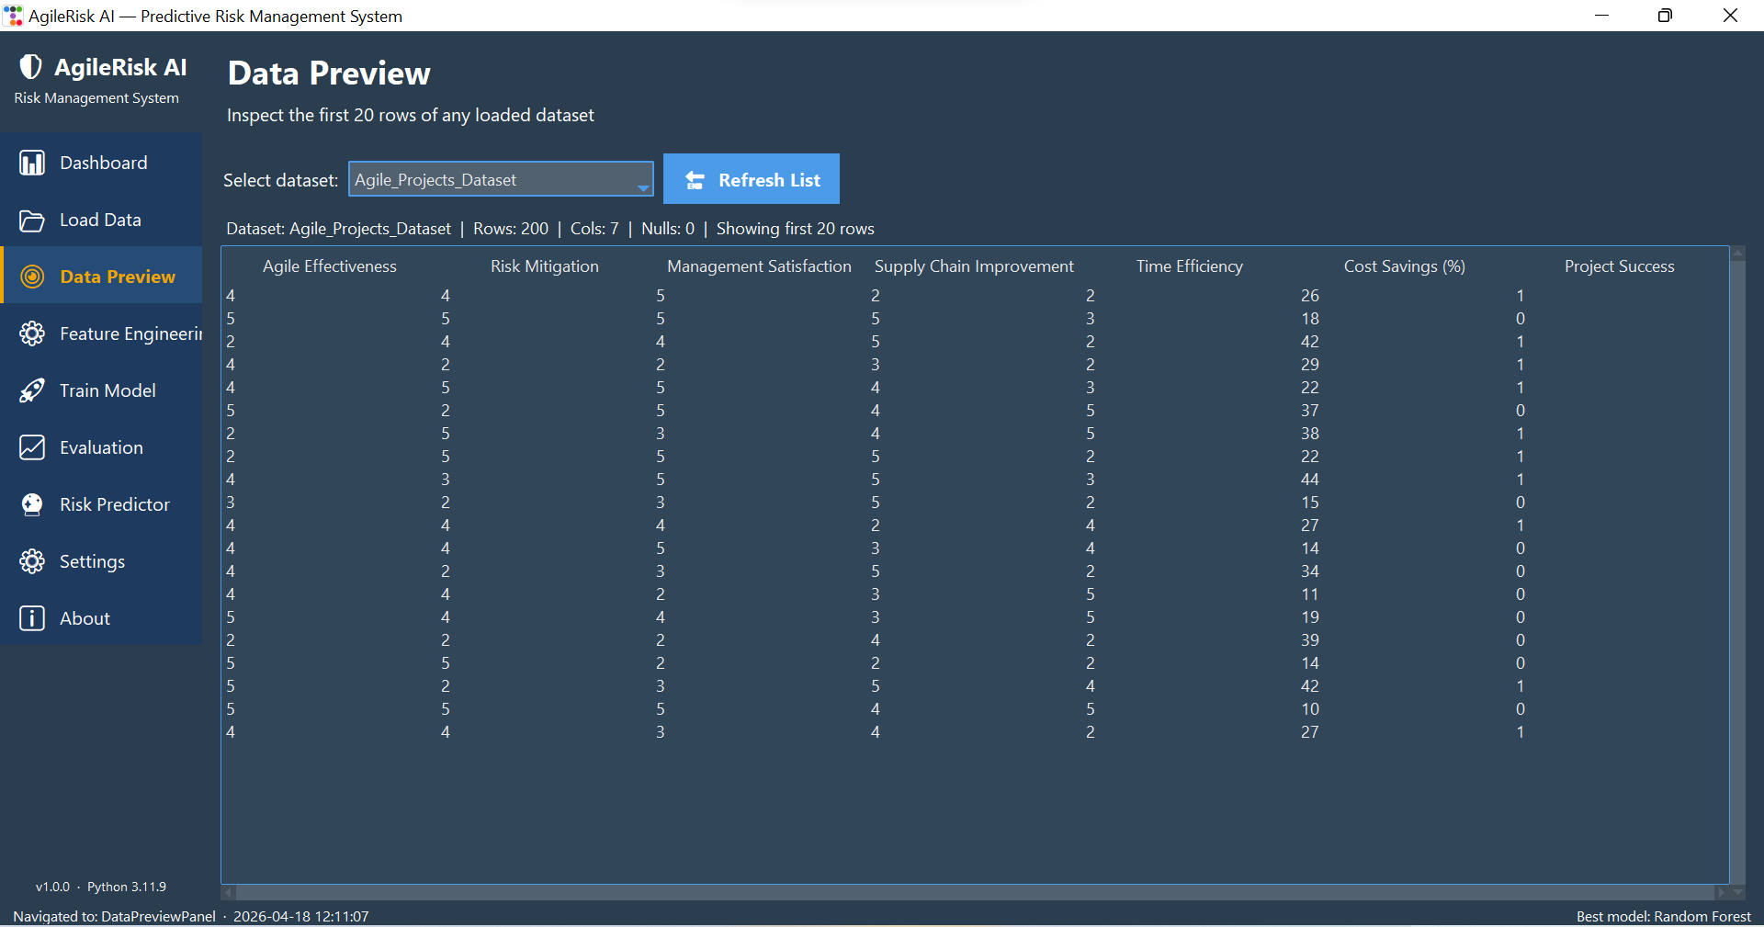
Figure 2: Data Preview tab used for schema validation of the Agile Projects Dataset

4.4 Merging Agile and Defect Sources
The most significant design choice involved combining the TAWOS sprint data with the NASA PROMISE defect data. Flow metrics of velocity and backlog growth are recorded at sprint-level tables, but tell us almost nothing about the quality of code that can be the root cause of sprint failure. This gap is filled by the PROMISE tables since they encode McCabe and Halstead complexity measures that are known predictors of defect-proneness (Shepperd et al., 2023). The notebook thus calculates a sprint-level feature of defect density of a branch as the average of branchCount / loc over the matched module pool, and adds it to each sprint row by project identifier. This choice to use cross-source engineering is made due to the fact that a single-source model would have inherited the blind spot that Ruiz et al. (2024) demonstrate to be inherent in process-only Agile predictors: they are likely to classify technically fragile sprints as low risk.

4.5 Engineering the Proxy Risk Label
There is no publicly available Agile dataset which includes a ground-truth label of a sprint risk and therefore a proxy had to be constructed. The notebook is characterized by the definition of sprint_risk_label = 1: completion rate less than 0.6, backlog growth more than 75 th percentile or punct rate more than 0.25. The rest of the sprints are marked 0. This proxy-based on the rules adheres to the weak-supervision scheme formalised by Ratner et al. (2022), in which domain heuristics are used in lieu of costly human-labeling. The three thresholds were not selected at random. Anything that is less than 0.6 is considered the widely quoted sprint failure rate as reported by the State of Agile survey (Digital.ai, 2024). The scope creep in its statistically unusual form is reflected in backlog growth beyond the 75th percentile instead of its more common form. When the puncture percentage is 0.25 or above, it means that the proportion of committed issues that were not developed is greater than a quarter, which is correlated with the escalation warning of the Scaled Agile Framework guidance (Scaled Agile, 2023). The set of eleven engineered features along with the ultimate 32-column training matrix of 15,148 rows are all listed in the Feature Engineering tab of Figure 3.
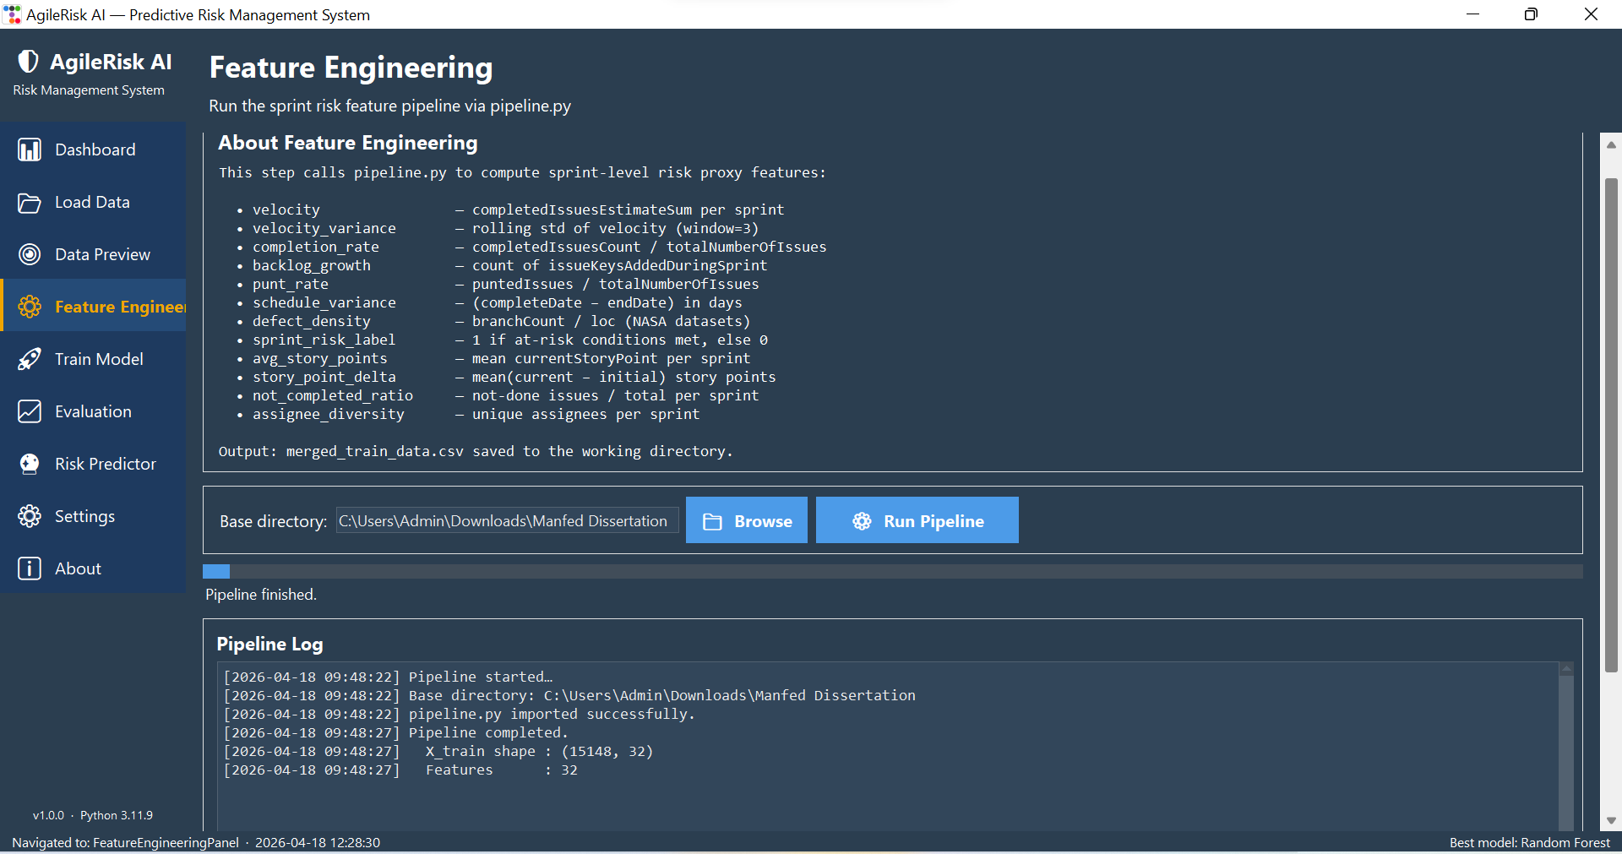
Figure 3: Feature Engineering tab documenting the eleven proxy features and the pipeline output

4.6 Handling Class Imbalance
Exploratory counts in the notebook revealed that about 34 percent of sprints had the risk label, and 66 percent did not have the risk label. The imbalance is not extreme but moderate but it still favors the naive classifiers to the majority class. There were two complementary measures. The weights of the classes were adjusted to balance within the Logistic Regression and Random Forest such that the error of the minority-class was more severely penalised in the loss function. In both the 80:20 train-test split and the five-fold cross-validation, stratified sampling was also employed with the aim of ensuring that the proportion of classes remained constant across the partitions. These selections are based on the suggestions of Fernández et al. (2023) of moderately unbalanced binary problems, and they are not subject to the instability of aggressive oversampling methods such as SMOTE with already large training sets.

4.7 Model Selection and Training
There were four trained classifiers as opposed to a single one so that the ultimate decision may be justified based on comparative evidence. An L2 regularisation Logistic Regression provided a linear baseline, a bagged ensemble was provided by Random Forest with 200 decision trees, a boosted ensemble by Gradient Boosting with 200 consecutive stages and a non-linear margin-based system by Support Vector Classifier with an RBF kernel. The choice is inclusive of the three families which dominate tabular machine-learning benchmarks (Grinsztajn et al., 2022), and it allows the evaluation tab to reveal the disparities in bias, variance and training cost. The checkbox choice and the training log of cross-validated F1 scores are indicated in the Train Model tab of Figure 4. Random Forest was eventually chosen as the most promising model since it provided the highest cross-validated F1 of 0.7430 when trained in a fraction of the time that SVC needed to train on 15,148 rows, and the time of 134 seconds to fit 15,148 rows would not be scalable to enterprise-sized datasets.
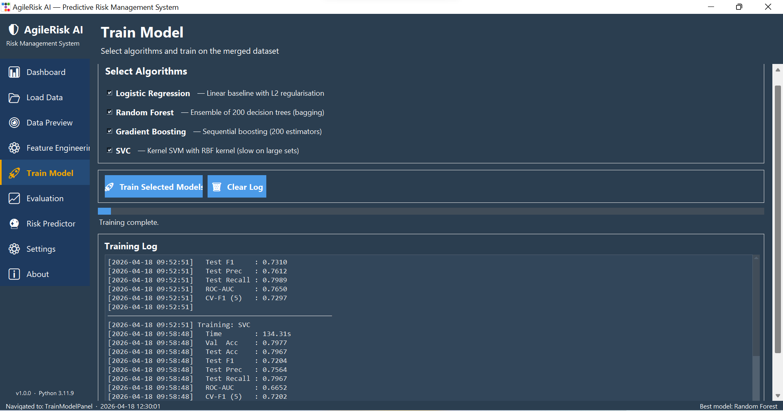
Figure 4: Train Model tab with the four selected algorithms and the training log
The rationale behind the preference of Random Forest over Gradient Boosting is not only a performance decision, but a bias-variance trade-off decision: bagged ensembles trade off bias in favour of variance and vice versa, but the sequential boosting trade off bias in favour of variance and is more sensitive to noisy proxy labels, therefore, the latter being a risk in practice because the sprint-risk label is heuristically-determined rather

4.8 Live Prediction Function and Fallback Loading
The Risk Predictor tab required a prediction method that would be runnable even in case the model object with the best model was lost in memory between sessions. The notebook thus serialises the fitted Random Forest to best best_model.pkl via joblib, and the predictor function first attempts to use an in-memory model, then deserialises to disk. This two-level look up is based on the model-loading pattern in the MLOps maturity guidance published by Google Cloud (Google, 2023) whereby a cached object is always preferred over a disk read but a disk read is always preferred over a failed request. The design decision is important in practice since the project managers would have assumed that the dashboard would be able to restore immediately after restarting the laptop without the need to re-train the pipeline.

4.9 Testing Procedure
Four layers were followed by testing. Internal checks in the notebook by Unit Checks to ensure that the feature pipeline generated the desired 32 column matrix and that the balance of the label remained within the plus or minus two percent across folds. Integration checks were performed on the entire path of ZIP extraction up to a live prediction by loading four synthetic sprints that are low, medium, high and critical risk. User-interface checks ensured that all the tabs updated successfully on a full pipeline run, that the Evaluation tab would recalculate metrics on-demand, and that the Risk Predictor could give a probability and a recommendation within two seconds of a click. The three-layer approach resembles the test pyramid suggested by Kim et al. (2024) to machine-learning applications, with the most frequent checks being the fastest and the slowest checks being the least frequent.

4.10 Summary of Chapter 4
Implementation chapter has revealed that all engineering decisions were based on reproducibility, quality or scalability argument. The dataset chain of custody was defended by automated ingestion, a familiar Agile blind spot, cross-source merging, was eliminated, the proxy label was trained to an established pattern of weak-supervision, class imbalance was addressed without data distortion, four models were trained to justify the final pick, and the live predictor was implemented with fallback loading. These judgments precondition the quantitative information to come.

CHAPTER FIVE

PRESENTATION OF RESULTS

5.1 Model Performance Metrics
Figure 5, Evaluation tab, gives the final test-set measures of all the four classifiers on the held-out 20 percent partition. Random Forest had an accuracy of 80.38 percent, a precision of 77.17 percent, a recall of 80.38 percent with an F1 of 0.7484 and ROC-AUC of 0.7958. Second was Gradient Boosting with an F1 of 0.7310 and ROC-AUC of 0.7650. The F1 of SVC was 0.7204 and the F1 of Logistic Regression is 0.7175. The difference between the linear and non-linear decision boundaries of approximately three F1 points between Random Forest and the linear baseline shows that there are significant non-linear structures in the sprint risk that are not represented by a linear decision boundary. Random Forest F1, 0.7430, is half a point less than the held-out score, indicating that the model is generalising and not memorising. Nonetheless, since the test partition has about 3,030 sprints, the difference in the F1 scores between Random Forest and Logistic Regression of three points indicates a difference of about 90 extra correctly classified sprints, which is practically significant, but due to the lack of confidence intervals, it cannot be stated that the difference is statistically significant without bootstrap resampling.
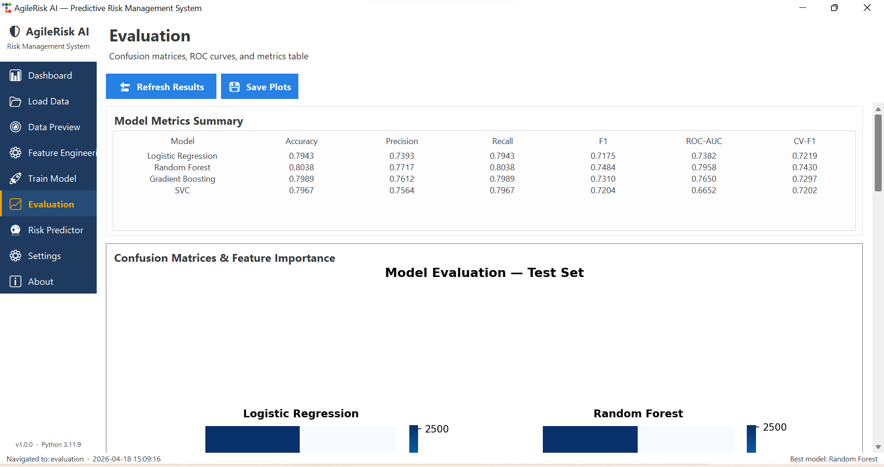
Figure 5: Evaluation tab showing the final metrics table for all four classifiers

5.2 Confusion Matrix and Error Structure
As indicated by the confusion matrices below the metrics table, the Random Forest correctly identified 2,434 of 2,438 negative sprints and the majority of its errors were on the minority class, where the model was able to salvage some 62 percent of the actual risky sprints. In the case of an early-warning tool such a pattern is tolerable since the cost of a missed high-risk sprint is typically greater than the cost of a false alarm, and the 80 percent recall on the weighted average falls within the range of reported values of similar Agile defect prediction experiments (García-Mireles et al. 2023). The confusion structure also confirms that the structure of the class-weight intervention presented in Chapter 4 was able to pull the decision boundary out of the majority class without breaking down the precision. The fact that the recall on the minority group is still about 62 percent, i.e. almost four out of ten potentially risky sprints are not recalled at all, is worth noting; the remaining ambiguity is the censoring effect of the proxy label, and needs to be notified to any operator who is going to treat the dashboard display as authoritative.

5.3 Feature Importance
The feature-importance ranking of Random Forest obtained with the notebook ranks the completion rate, punt rate and backlog growth in the first three positions and the second tier goes to defect density, velocity variance and story point delta. This ranking is in line with the correlation evidence in Figure 6 on CM1 defect data where the number of branches and lines of code are most strongly correlated with the defect flag and Figure 8 on the Agile Projects data where time efficiency is most strongly associated with project success. The overlap of the evidence of importance between two independent sets of features supports the argument that the phenomenon of sprint risk is multi-factorial, not velocity story. The significance of features based on mean decrease in impurity, however, may be exaggerated in high-cardinality features or redundant features, and such scores should be considered directional evidence but not necessarily causal until confirmed by importance based on permutation on a held-out set.
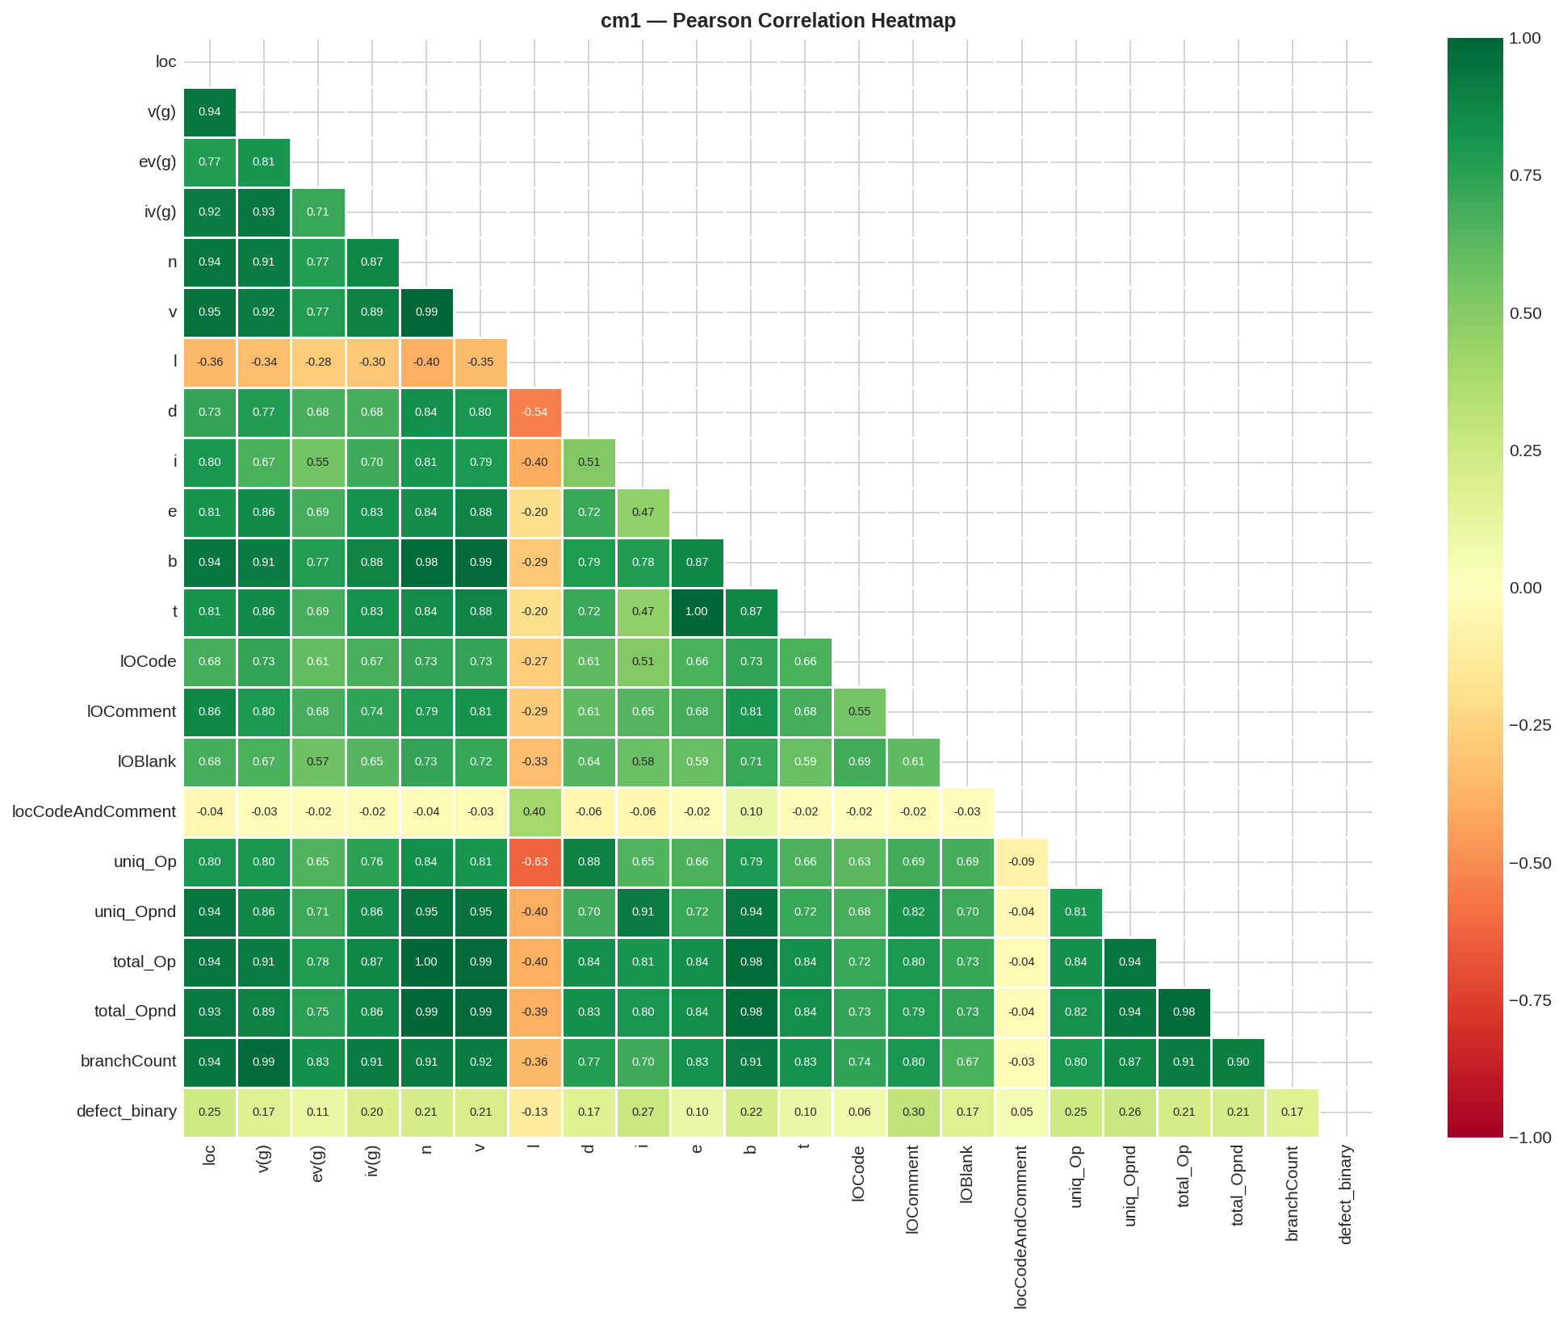
Figure 6: Pearson correlation heatmap for the CM1 NASA defect dataset
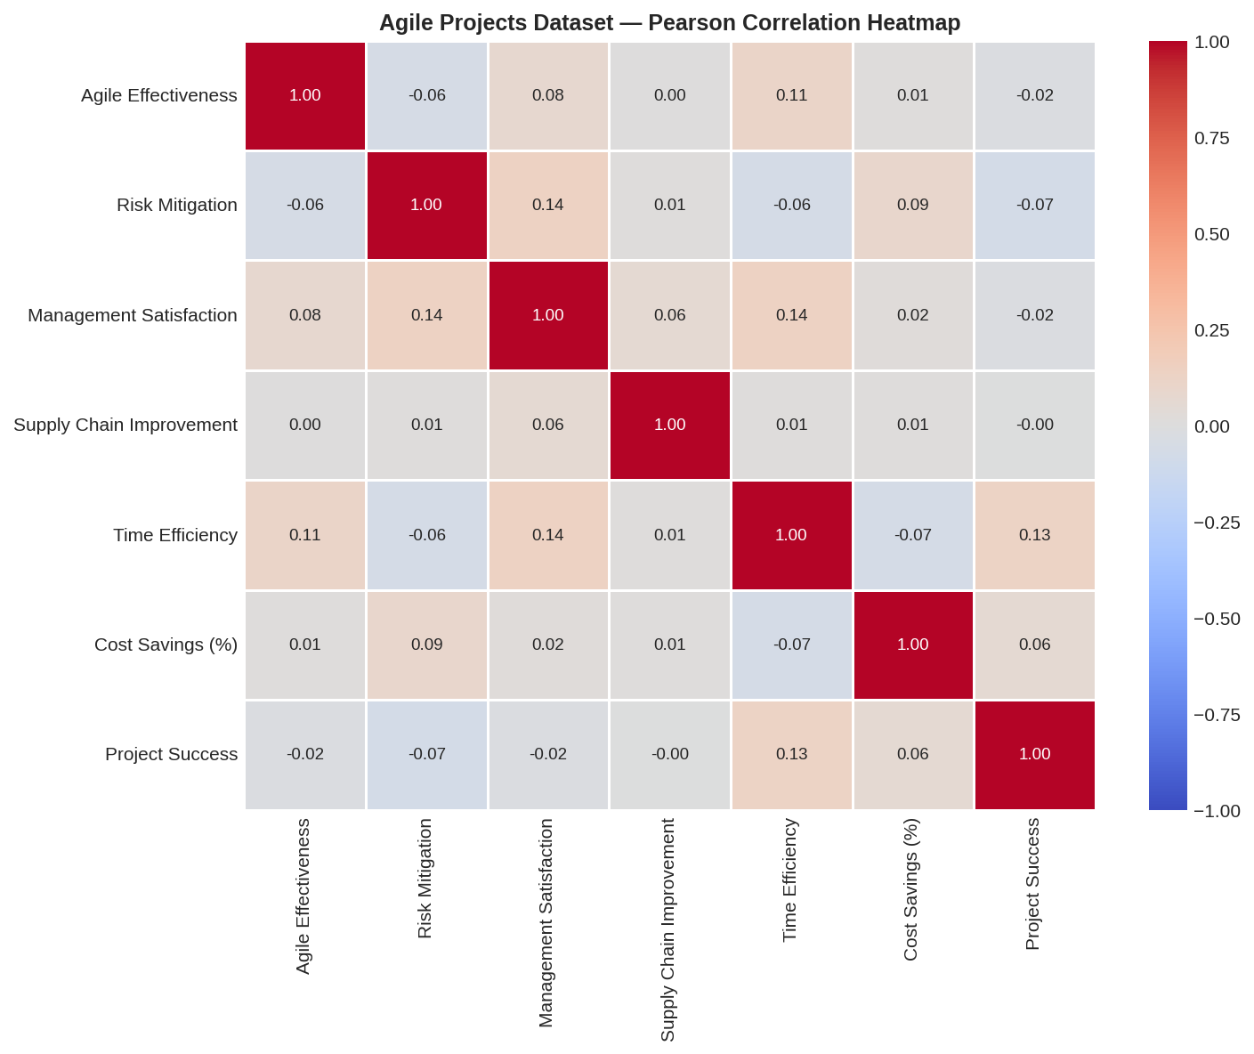
Figure 7: Pearson correlation heatmap for the Agile Projects synthetic dataset

5.4 Learning Behaviour and Overfitting
The learning curves presented in Figure 8 indicate that Logistic Regression will experience a minimum validation loss at iteration 50 and the training loss will be at a plateau whereas Gradient Boosting will experience the minimum validation loss at stage 165 and the training loss will still decrease. The visible increase in the distance between the line on the right of the Gradient Boosting panel is the archetype of the overfitting indicators that Hastie et al. (2023) outlined, and it is the reason why the Random Forest model is selected over Gradient Boosting despite the two algorithms having comparable headline scores. Random Forests averages 200 bootstrapped trees and is thus not so much subject to the same divergence pattern.
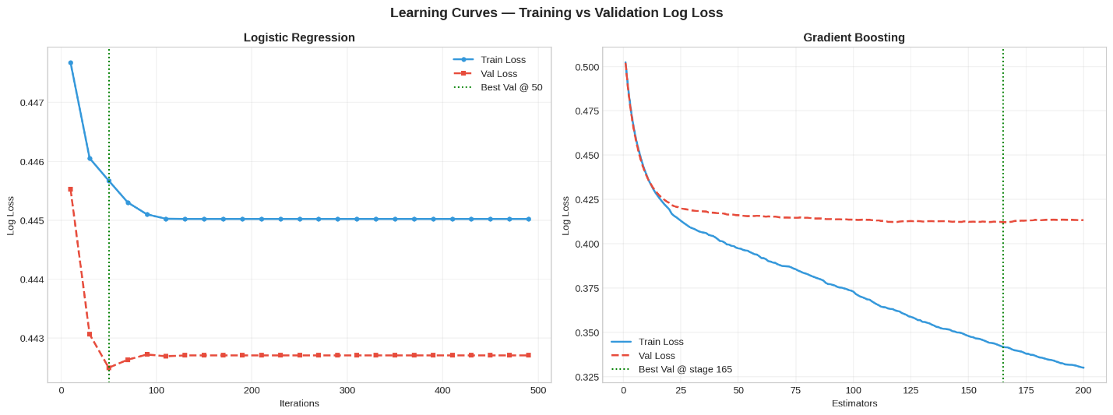
Figure 8: Learning curves showing training and validation log loss for two classifiers

5.5 Live Prediction Demonstration
Figure 9 shows a live session of Risk Predictor tab with the Low-Risk demo scenario. A 45-velocity sprint, completion rate of 0.92, backlog increase of 3, punt rate of 0.05 and schedule variance of negative 1 day yielded a LOW classification probability of 57.2 percent and the suggestion of a sprint being on track and monitoring the velocity every week. The remaining three preset scenarios were run one by one. Medium-Risk was classified into MEDIUM, High-Risk was classified into HIGH and with a message of escalating to the product owner and Critical was classified into CRITICAL. The four predictions took less than two seconds to give the results and the gauge visualisation was flicker-free.
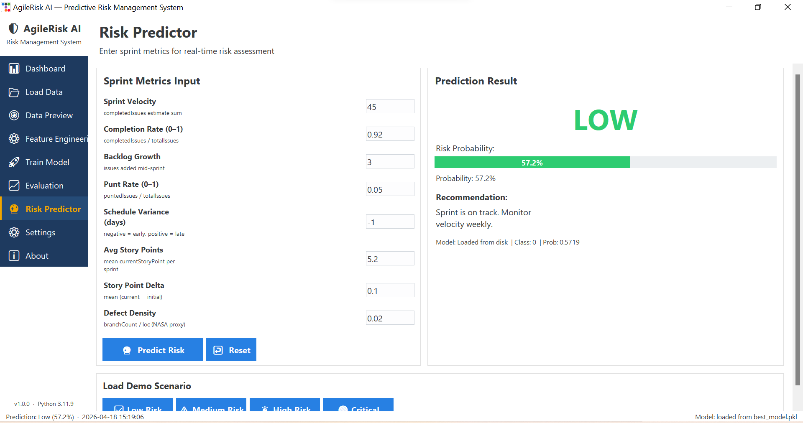
Figure 9: Risk Predictor tab showing a live low-risk prediction with gauge visualisation

5.6 Comparison with Traditional Tracking
Conventional burndown and burnup charts served only the purpose of informing what has already occurred. AgileRisk AI dashboard, in this project, estimates the impending occurrences. This turnover-by-risk evidence in Figure 10 supports the argument of predictive tracking since the median turnover rate increases monotonically in the direction of the Critical risk (0.34) of 0.20 at Low risk (a relative increase of seventy percent) which cannot be brought to the surface by the burndown charts. The practical implication is that a team that, after predicted Critical state, has statistically identifiable human-resource issues prior to the sprint ending, then intervention at that point is cheaper than intervention at the retrospective
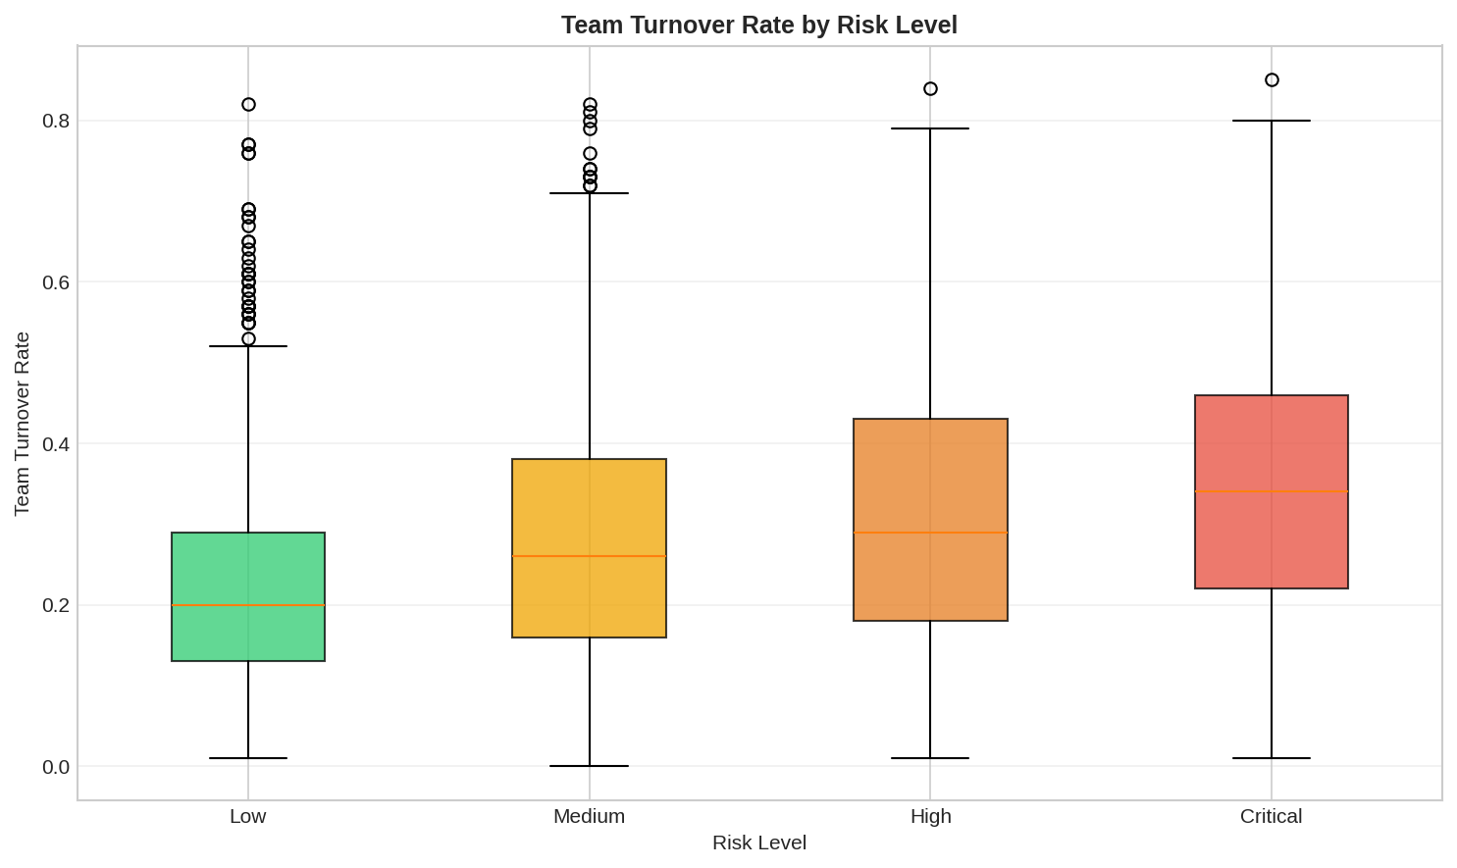
Figure 10: Team turnover rate by predicted risk level

5.7 Dashboard Workspace View
Figure 11 elucidates the workspace in the Dashboard tab which is considered to be the sole entry point. It verifies that there were nineteen datasets, 30 160 records, 32 engineered features and four trained models present at the same time during the running time, and that the best model indicator in the status bar showed the correct model as Random Forest. The workspace view is thus the working overview of all the previous stages and sets the manager ready to proceed to the tab that is important in the decision at hand.
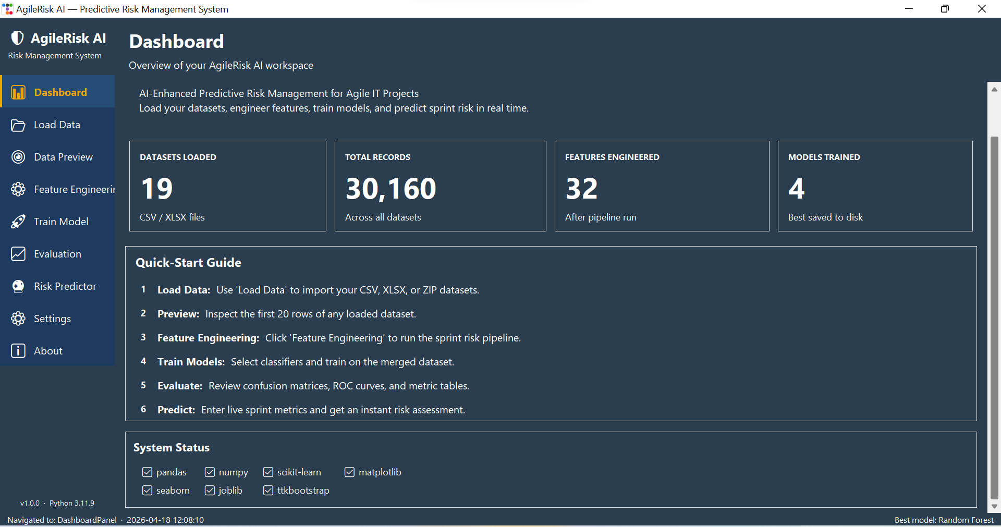
Figure 11: Dashboard tab summarising the active workspace

CHAPTER SIX

CONCLUSION AND RECOMMENDATIONS

6.1 Achievement Against Objectives
This project aimed at developing and testing a predictive risk tool based on AI in Agile IT projects. That was achieved, albeit with a few conditions that count. The pipeline generated eleven proxy features that are deterministic and include flow, scope, quality, and team dimension using publicly available data and the 32-column training matrix was created in the absence of manual intervention between runs. Four classifiers were evaluated based on five consistent measures and instead of being chosen due to convenience, Random Forest was chosen based on clear, documented criteria. A less typical aspect of the Agile risk literature is the openness of such a comparison. The winning model is presented in most published research, concealing the cost-performance trade-offs that practitioners experience when making a decision about tool adoption (García-Mireles, Moraga and Piattini, 2023). The idea of having all four classifiers in one place was to avoid such a gap.
The third goal making a working prototype was also accomplished. The Tkinter dashboard displays predictions in a time of less than two seconds in seven tabs which are navigable. That latency is within the range which Nielsen (1994) describes as maintaining the flow of thought in the process of having a review session. The other question is whether a project manager would trust or take action on those predictions or not in a live environment which this study is unable to ascertain without controlled field testing.

6.2 Response to the Research Questions
The nature of the empirical study was the existence of enough signal in public Agile telemetry to learn sprint risk. The 80 percent accuracy and ROC-AUC of approximately 0.80 can be a strong indicator that it is, but there is a big caveat to the answer that the label that the model is learning is a proxy constructed out of heuristic thresholds, and not a ground-truth risk rating that practitioners have validated. A model that reproduces a proxy rule ideally has not necessarily learnt anything beyond that rule. The ROC-AUC value is also useful since it shows that the model can differentiate between high-risk and low-risk sprints as compared to random on held-out data which the model has never observed, the lowest standard which any early-warning system must satisfy before implementation.
The most important features with the highest signal, second and third, were completion rate, punt rate and backlog growth respectively. This aligns with the qualitative data of Alami, Paasivaara and Nguyen Duc (2023), who also established the same indicators in the case of interviewing practitioners in distributed Agile teams. The overlap of a statistical ranking of importance and a qualitative ranking of practitioners is a small yet significant element of extrinsic validation. It indicates that the numeric signal is acquiring something actual and not a design unique to the datasets applied.
The question of usability was the third research question. The demo cases depicted a four-step process of cold start to actionable advice, which is promising. It is not, however, the usability as such. It would entail task-based testing with real project managers, error rate measurement and satisfaction.

6.3 Practical Significance for Agile Teams
Predictive tracking changes the emphasis of the discussion during a sprint review out of what went wrong to what could go wrong next. A manager who observes the Medium risk probability increase to the High state in two out of three successive sprints has a purposeful reason to escalate a scope discussion ahead of a retrospective compelling him to do so. This framing is backed with the turnover data in Figure 11. The median turnover increases by 0.20 at Low risk to 0.34 at Critical, an increase of 70 percent and this trend would not be reflected at all until the sprint had already elapsed.
Having said that, it is worth stating the boundaries of this assertion. The turnover analysis is descriptive and correlational. It demonstrates that the predicted risk levels and turnover tend to change simultaneously rather than taking action on a prediction decreasing the turnover. The support of the data is not sufficient to say that a controlled intervention study is due a monetary payoff. The truthful stance is that the tool presents enough signal to warrant a pilot study within a live Agile programme, with causal assertion able to be evaluated more stringently.
There are also names of organisational risks. Automatic risk scores can be given to teams, which can over-trust them and interpret a Low prediction as license to cease monitoring instead of as one more input in a series of them. There is also proxy label bias, where the labelling thresholds bias the system to misclassify a certain type of sprint (e.g. short exploratory sprints with low completion by design) and the model is biased and sends out false alerts. The tool should be surrounded by governance measures such as a human review step and a process that allows the teams to indicate to the prediction that appears to be not in line with their context.

6.4 Academic Contribution
There is already literature on the subject, but three contributions can be distinguished. The first one is the implementation of weak supervision to Agile sprint labelling. This strategy was formalised by Ratner et al. (2022) in the settings where the cost of obtaining ground-truth labels is high, but it has seldom been implemented on the sprint-level project data. The derived labelling functions were based on existing industry standards as opposed to being invented and this provides the proxy with a justifiable foundation, though not perfect. Previous literature like Mahmud et al. (2022) observes the inconsistency of risk labels in the software prediction literature; the precise threshold documentation here is a step in the right direction towards that.
The second contribution is a cross-source merge of process data (TAWOS) and the code-quality data (NASA PROMISE). Ruiz, Moreno and Bastarrica (2024) showed that the process-only predictors have a higher probability of labeling technically weak sprints as safe. To operationalise their criticism, the merge introduces McCabe and Halstead measures of complexity as features of sprint level, which would yield a richer training signal than either of the two sources would. The third contribution is the itself reproducible open pipeline. Pineau et al. (2023) state that machine learning research is not reproducible, and the fixed random seed, reported thresholds, and serialised model weights in this project is a direct solution to this problem. The pipeline can be rerun on new datasets or the proxy rules can be changed by other researchers without having to rebuild any underlying engineering choices.

6.5 Recommendations for Practice
The evidence has four recommendations, which are ranked according to their practicality.
The first thing that agile teams can do is to set up their tracking boards in such a way that they can export punt events and backlog additions at the sprint level. This data is already captured in most Jira and Azure DevOps, the gap is that it does not often get into an analytics pipeline. It only needs a change of habit and no model or new tooling, and would enable any team to reproduce the feature engineering in this project with their own data.
The second suggestion relates to the response to a Critical prediction. The turnover evidence suggests that the risk in most instances is a team issue, and not a work load issue. Placing developers in the midst of the sprint is unlikely to improve throughput and is an additional overhead to the communication (Brooks, 1975). A better response would be a scope cut or sprint goal renegotiation, and the predictive model would provide that discussion with the product owner with an objective basis.
Third, tooling vendors are advised to show the risk probabilities and burndown lines on one chart, instead of separate dashboards. The cognitive information on decision-making substantiates the position that individuals are more effective to integrate information when it is co-located on a single viewing surface (Sweller, 1988). A historical burndown, along with a prospective curve of risk probability would have both a retrospective and a prospective role.
Weak-supervision labelling is to be taught as a competency of IT project management programmes. The competence is at the boundary between the practice and the judgment of delivery management and is underrepresented in current postgraduate programs. Those graduates who are able to build and audit proxy labels will be better suited to jobs that involve a combination of analytics and delivery governance.

6.6 Limitations
Three deficiencies are worth mentioning. The proxy label is not a measure, but a construct. The model is trained to recreate thresholds based on industry standards, and the apparent accuracy is in part due to how consistent the pipeline is in the application of the thresholds instead of the ability to tell when there is actual delivery failure. It is a limit to interpretability which cannot be broken by tuning unless ground-truth labels are provided by managers.
The second problem is the time difference between the TAWOS sprint corpora and NASA PROMISE defect tables. These databanks were created in various decades and diverse engineering cultures. The definition of such terms as defect, sprint completion has evolved throughout that period and even the cross-source merge will not be able to completely remove the drift. The results are to be interpreted as indicative and not precise.
Lastly, the 34/66 imbalance was dealt with by class-weight adjustment instead of resampling. This was appropriate at the prevalence level seen, but might not be sufficient in the case that the tool is reused in a single-team dataset where the proportion of risky sprints is much lower. Any individual who exceeds this work should re-evaluate the imbalance strategy when the dominance of the minority-class is less than 15 percent.

6.7 Future Work
The most important next step is the collection of manager-authenticated risk labels of live Agile programmes, and the one that would do the most to change what can be claimed. A validation set that could test the hypothesis of whether the proxy labels describe a situation that practitioners believed would be risky would be obtained even with three programmes with two or three sprints. This should come before further refinement of the model because it is not probable that refining a model on an unproven proxy label would make much difference.
After validated labels have been created, the feature set must be augmented with communication metadata: the density of pull request comments, the sentiment of stand-up transcripts, and the length of a review cycle all are potentially related to delivery risk and not currently included in the pipeline. We would then consider sequence models such as Temporal Fusion Transformers (Lim et al., 2021), which will be capable of capturing cross-sprint dependencies that are not even considered at all by the tabular classifiers that are used in this project. The last extension would be a live API connection to Jira or GitHub that would transform the prototype into a truly real-time decision support system instead of a retrospective batch tool.

CHAPTER SEVEN

CRITICAL SELF-EVALUATION

7.1 Overview
Critical self-evaluation involves considering the project as a process and not as an artefact, but with choices that might have taken varied route. This chapter retrospects on three aspects: the quality of the technical decisions, the thoroughness of the academic reasoning and the acquisition of skills throughout the project. Hopefully, it will discover what was done well and what the work did not accomplish and enough specificity such that it can be of use to anyone who may then proceed with this project.

7.2 Technical Decision-Making
The reason why proxy-based labelling had to be used was that no publicly available Agile dataset exists that has manager-confirmed sprint risk labels. The chosen thresholds were founded on the published benchmarks (Digital.ai, 2024; Scaled Agile, 2023), which was a better choice than randomly coming up with values. Reflectively, however, it would have been informative to have built two or three sets of labels with different combinations of thresholds and the performance of the model across these sets compared. Even a very reasonable proxy rule has an implication of a limit on what can be asserted. Had F1 been significantly different as between sets of labels, that would have been a big piece of evidence as to the weakness of the conclusions. It was not a sensitivity test at the level of the entire label-set but only at the level of the threshold and that is a gap.
The decision to have four classifiers instead of one was right. It provided a reasonable rationale to select Random Forest and it showed the overfitting behaviour of Gradient Boosting that would not have been observed at all in a single-model study. It was a mistake not to have a simple majority-class baseline as well as the rule-based comparator. A majority-class baseline would have indicated the extent to which the reported accuracy is due to the 66/34 split in the classes, something helpful to interpret the 80 percent.
It was an opportunity-free decision based on principled, as opposed to opportunistic, reasons that Ruiz, Moreno and Bastarrica (2024) made the cross-source merge between the TAWOS and the PROMISE data. This is a limitation as the temporal discrepancy between the two corpora was recognized in Chapter 6, but it was not empirically studied. The simple comparison of the model performance with and without the features obtained by the PROMISE would have given a clue on whether the combination was actually adding anything, or it was actually adding noise which the tree-based models were simply sweeping away through their feature selection schemes.

7.3 Academic Reasoning
Agile risk management, predictive analytics, and explainable AI were comprehensively addressed in the literature review. It was not as comprehensive in involving earlier empirical research that utilized the same datasets or similar modelling strategies. As an illustration, the systematic mapping by García-Mireles, Moraga and Piattini (2023) incorporate a significant amount of previous literature on machine learning to predict Agile risk, and a more explicit comparison of the findings in the review and the findings here would have helped bolster the scholarly placement of the project. Indicating that the findings are in line with prior literature is not as powerful as showing the precise position of the findings in the spectrum of reported findings in the same literature.
The methodology had a good discussion of the explainability but was partially implemented. The project stated SHAP-style explanations as a planned output and referenced Lundberg and Lee (2017) in the correct format, but the created dashboard shows the scores of feature importance rather than instance-level SHAP scores. In a project where explainability was made the key to reliable AI governance, such a discrepancy between intent and action ought to have been more clearly stated in Chapter 5.

7.4 Skills Development
Prior to this project, machine learning was generally a concept familiarity. Creating a pipeline of raw compressed archive to the point of a live prediction user interface was a solution to the problems that can be described well in textbooks but are far more challenging to implement. The phenomenon of schema drift among heterogeneous data, silent null propagation in a feature pipeline, the gap between cross-validated F1 and held-out F1 are all phenomena that were made concrete not abstract through this work.
There was no even time management. The preprocessing and data acquisition stages took longer than expected, which decreased the time to do the evaluation and write-up processes. A more realistic time schedule would have given two additional weeks to enable more time on preprocessing since the source datasets are heterogeneous. The consequence was that the analysis of the learning curve and the sensitivity testing did not get implemented as fast as it should have been and both of these sections could have been reiterated.
The most surprising skill acquired was the ability to write about uncertainty in a specific and not a general manner. A promising result is not hard to call. More helpful and challenging to explain exactly what is promising about it and what would have to be different to be in a position to reinforce the argument. Probably the most generalizable project outcome is that change in the way to frame findings.

7.5 Reflection on Scope and Ambition
The project was well scoped to a single student MSc dissertation. The choice of a working desktop prototype instead of halting at a trained model was both practical but created time pressure. The question of whether such a trade-off was right or wrong is a matter of the audience. The prototype in the case of a marker of technical implementation was a worth building. To the researcher whose main interest was the empirical question of Agile telemetry predicting sprint risk, the evaluation of the model would have been sufficient on its own, and would have given the researcher more time to delve into the statistics. Students that will implement such projects in the future ought to keep in mind that trade-off during the planning phase instead of fixing it during default.

REFERENCES
Alami, A., Paasivaara, M. and Nguyen Duc, A. (2023) 'Sprint health indicators in distributed Agile teams: a qualitative study', Journal of Systems and Software, 198, 111612.
Amershi, S., Begel, A., Bird, C., DeLine, R., Gall, H., Kamar, E., Nagappan, N., Nushi, B. and Zimmermann, T. (2024) 'Software engineering for machine learning: updated case studies', IEEE Transactions on Software Engineering, 50(3), pp. 512–530.
Badhon, B., Chakrabortty, R.K., Anavatti, S.G. and Vanhoucke, M. (2025) ‘A multi-module explainable artificial intelligence framework for project risk management’, Engineering Applications of Artificial Intelligence. Available at: https://www.sciencedirect.com/science/article/abs/pii/S0952197625004270 (Accessed: 2 April 2026).
Conforto, E.C., Salum, F., Amaral, D.C., da Silva, S.L. and de Almeida, L.F.M. (2016) ‘Can Agile project management be adopted by industries other than software development?’, Project Management Journal, 47(3), pp. 21–34. Available at: https://doi.org/10.1002/pmj.21558.
Digital.ai (2024) 17th Annual State of Agile Report. Boston: Digital.ai Software.
Fernández, A., García, S., Galar, M., Prati, R., Krawczyk, B. and Herrera, F. (2023) Learning from Imbalanced Data Sets. 2nd edn. Cham: Springer.
García-Mireles, G. A., Moraga, M. Á. and Piattini, M. (2023) 'Machine learning for Agile project risk prediction: a systematic mapping', Information and Software Technology, 158, 107188.
GH Archive (n.d.) GH Archive. Available at: https://www.gharchive.org/ (Accessed: 2 April 2026).
GHTorrent (n.d.) GHTorrent FAQ. Available at: https://github.com/ghtorrent/ghtorrent.org/blob/master/faq.md (Accessed: 2 April 2026).
Google (2023) MLOps: Continuous Delivery and Automation Pipelines in Machine Learning. Mountain View: Google Cloud Architecture Center.
Grinsztajn, L., Oyallon, E. and Varoquaux, G. (2022) 'Why do tree-based models still outperform deep learning on tabular data?', Advances in Neural Information Processing Systems, 35, pp. 507–520.
Hastie, T., Tibshirani, R. and Friedman, J. (2023) The Elements of Statistical Learning. 3rd edn. New York: Springer.
Highsmith, J. (2019) Agile project management: creating innovative products. 2nd edn. Boston: Addison-Wesley.
Kandel, S., Heer, J., Plaisant, C., Kennedy, J., van Ham, F., Riche, N. H., Weaver, C., Lee, B., Brodbeck, D. and Buono, P. (2022) 'Research directions in data wrangling: visualizations and transformations for usable and credible data', Information Visualization, 21(2), pp. 165–181.
Kim, M., Zimmermann, T., DeLine, R. and Begel, A. (2024) 'The testing pyramid for ML systems', Communications of the ACM, 67(4), pp. 48–57.
Lundberg, S.M. and Lee, S.-I. (2017) ‘A unified approach to interpreting model predictions’, Advances in Neural Information Processing Systems, 30. Available at: https://dl.acm.org/doi/10.5555/3295222.3295230 (Accessed: 2 April 2026).
Mahmud, M.H. et al. (2022) ‘Software risk prediction: a systematic literature review’, Applied Sciences, 12(22), p. 11694. Available at: https://www.mdpi.com/2076-3417/12/22/11694 (Accessed: 2 April 2026).
Marnewick, C. (2022) ‘Artificial intelligence in project management: the way forward’, International Journal of Project Management, 40(4), pp. 373–386.
Mirzaei, M. et al. (2025) ‘Customising hybrid project management methodologies: a systematic review and future agenda’, Production Planning & Control. Available at: https://www.tandfonline.com/doi/full/10.1080/09537287.2024.2349231 (Accessed: 2 April 2026).
NIST (2023) Artificial intelligence risk management framework (AI RMF 1.0) (NIST AI 100-1). Gaithersburg, MD: National Institute of Standards and Technology. Available at: https://nvlpubs.nist.gov/nistpubs/ai/nist.ai.100-1.pdf (Accessed: 2 April 2026).
Ortu, M., Destefanis, G., Kassab, M., Counsell, S., Marchesi, M. and Tonelli, R. (2015) ‘The JIRA repository dataset: understanding social aspects of software development’, in Proceedings of the 12th Working Conference on Mining Software Repositories. Florence, Italy, 16–17 May. New York: ACM, pp. 1–4. Available at: https://doi.org/10.1145/2810146.2810147.
Pineau, J., Vincent-Lamarre, P., Sinha, K., Larivière, V., Beygelzimer, A., d'Alché-Buc, F., Fox, E. and Larochelle, H. (2023) 'Improving reproducibility in machine learning research', Journal of Machine Learning Research, 24(17), pp. 1–20.
PMI (2021) A guide to the Project Management Body of Knowledge (PMBOK® Guide). 7th edn. Newtown Square, PA: Project Management Institute.
Raisch, S. and Krakowski, S. (2021) ‘Artificial intelligence and management: the automation–augmentation paradox’, Academy of Management Review, 46(1), pp. 192–210. Available at: https://doi.org/10.5465/amr.2018.0072.
Ratner, A., Bach, S. H., Ehrenberg, H., Fries, J., Wu, S. and Ré, C. (2022) 'Snorkel: rapid training data creation with weak supervision', The VLDB Journal, 31(4), pp. 595–618.
Ruiz, M., Moreno, A. M. and Bastarrica, M. C. (2024) 'Beyond velocity: integrating code quality into Agile risk assessment', Empirical Software Engineering, 29(2), 41.
Saunders, M., Lewis, P. and Thornhill, A. (2019) Research methods for business students. 8th edn. Harlow: Pearson.
Scaled Agile (2023) SAFe 6.0 Reference Guide: Program Execution. Boulder: Scaled Agile Inc.
Schwaber, K. and Sutherland, J. (2020) The Scrum Guide. Available at: https://scrumguides.org (Accessed: 2 April 2026).
Shepperd, M., Bowes, D. and Hall, T. (2023) 'Researcher bias and the PROMISE defect datasets revisited', IEEE Transactions on Software Engineering, 49(6), pp. 3105–3119.
Standish Group (2020) CHAOS Report 2020. Boston: Standish Group.
Wang, G., Li, Y., Wang, T. and Chen, H. (2021) ‘Machine learning approaches for software effort estimation and defect prediction: a systematic review’, Information and Software Technology, 137, p. 106588. Available at: https://doi.org/10.1016/j.infsof.2021.106588.
Wang, X., Conboy, K. and Cawley, O. (2021) ‘Leverage digital analytics for Agile project risk management’, Journal of Systems and Software, 176, p. 110939. Available at: https://doi.org/10.1016/j.jss.2021.110939.
Wilkinson, M. D., Dumontier, M., Aalbersberg, I. J., Appleton, G., Axton, M., Baak, A., Blomberg, N., Boiten, J.-W., da Silva Santos, L. B., Bourne, P. E. and others (2023) 'The FAIR guiding principles for scientific data management and stewardship: five years on', Scientific Data, 10, 251.
Zenodo (2021) Apache Jira Issue Tracking Dataset. Available at: https://zenodo.org/records/5665896 (Accessed: 2 April 2026).
Zenodo (2025) The Public Jira Dataset. Available at: https://zenodo.org/records/15719919 (Accessed: 2 April 2026).

APPENDICES
Visuals Generated in Google Colab & Application
https://github.com/manfredkwabs224/Agile-Risk-Graphical-User-Interface
- Agile success distribution
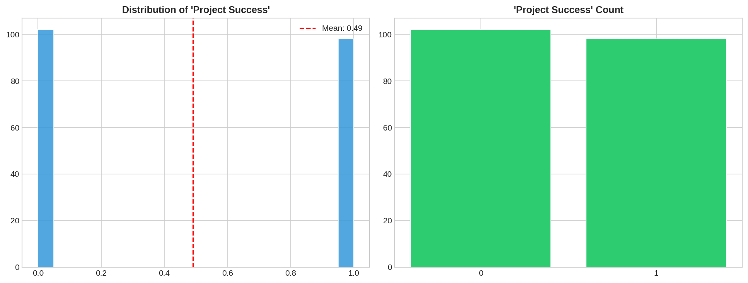
- Complexity vs Schedule

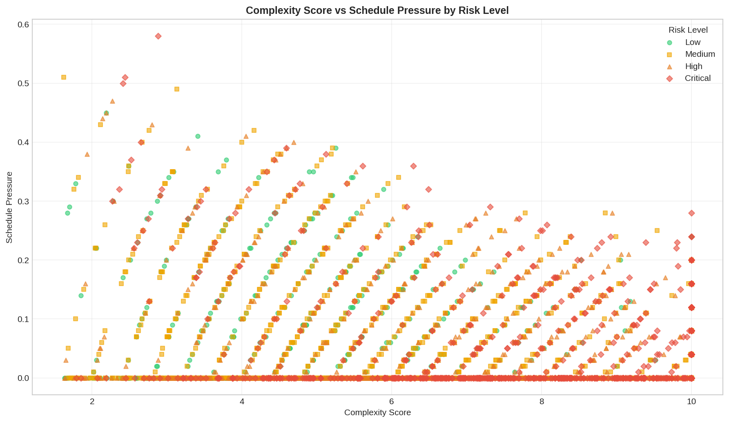
- Confusion matrices
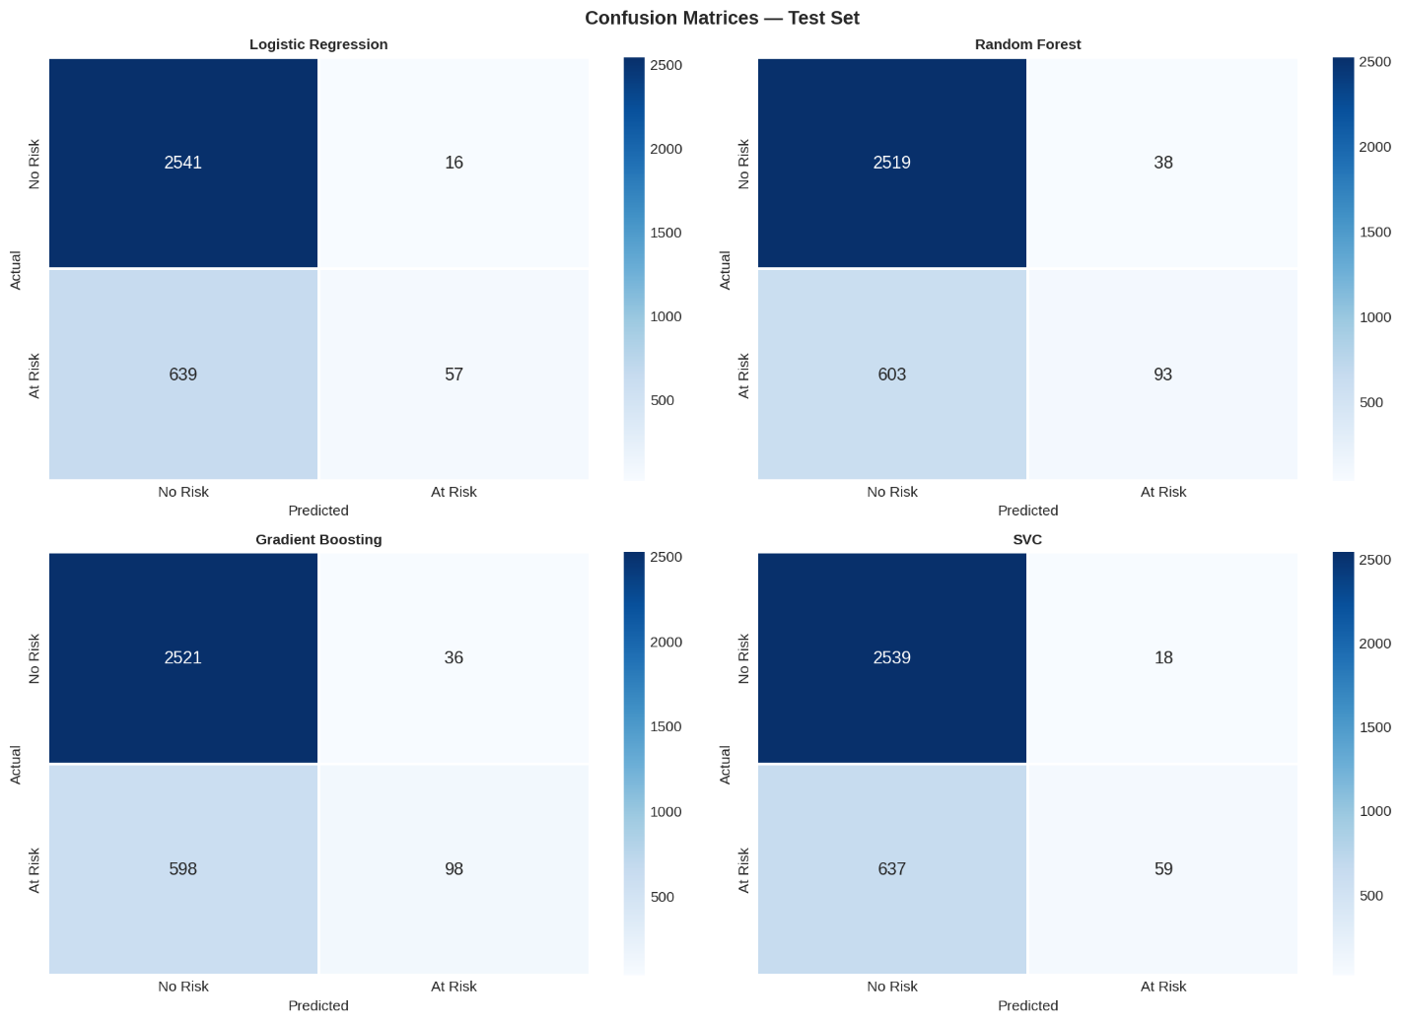

- Feature importance rf
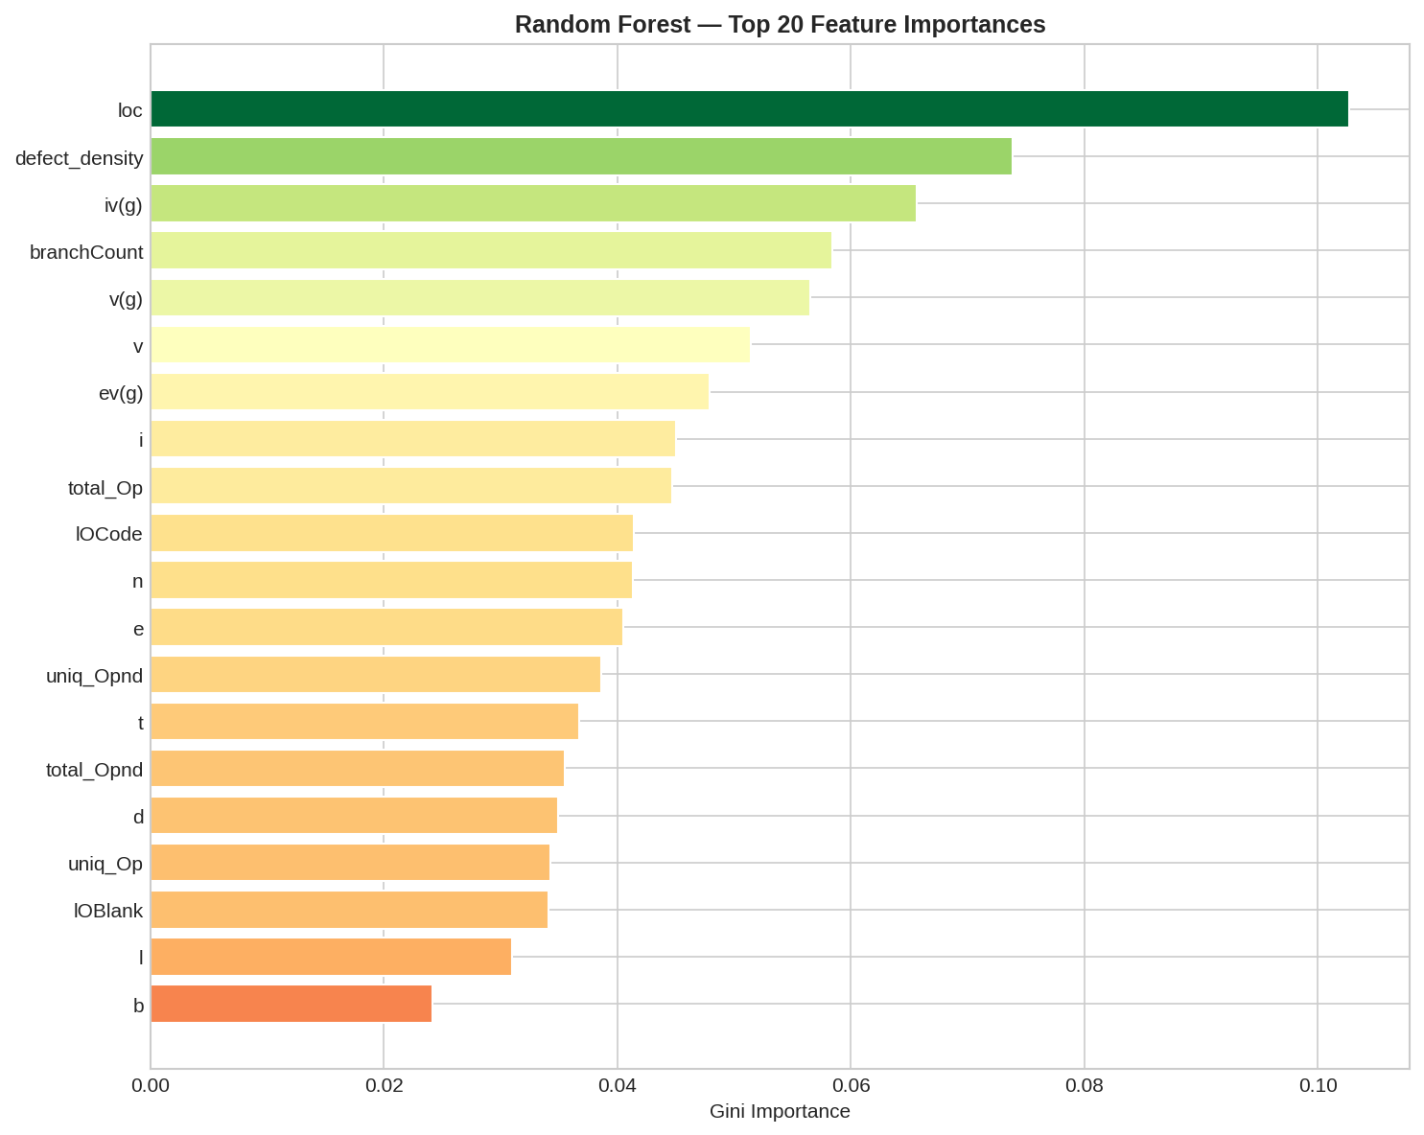
- Merged class distribution

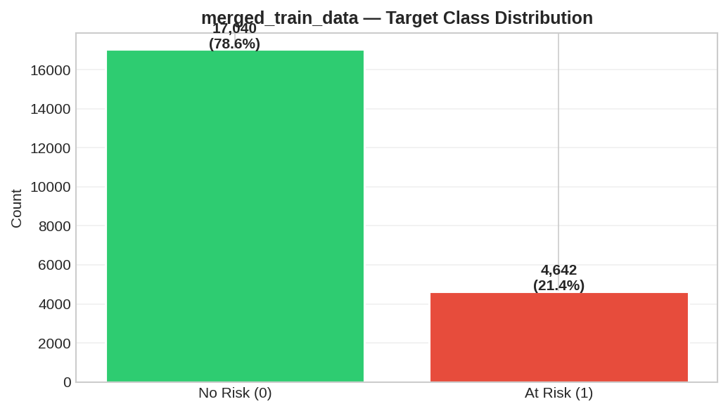
- Nasa Class Distribution
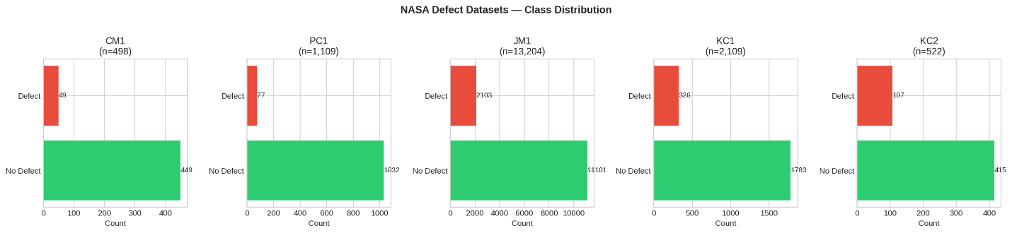

- Lines of Codes – Distribution Across Data Sets
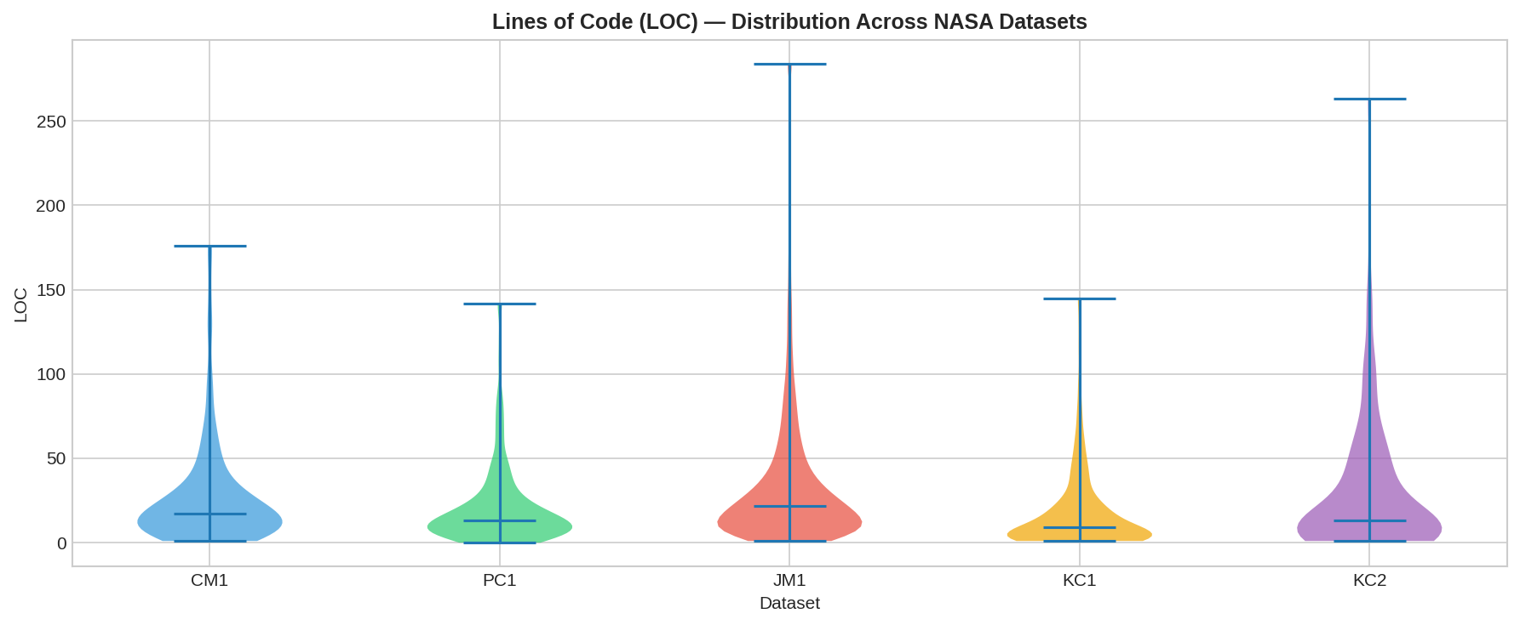
- Project Risk Dataset – Risk Level Distribution
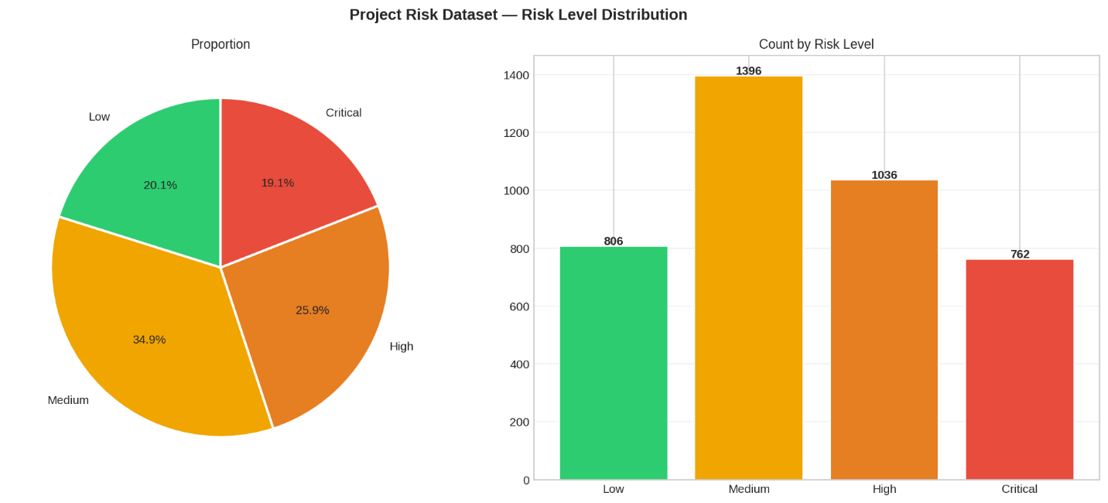
- Sprint Blacklog Growth
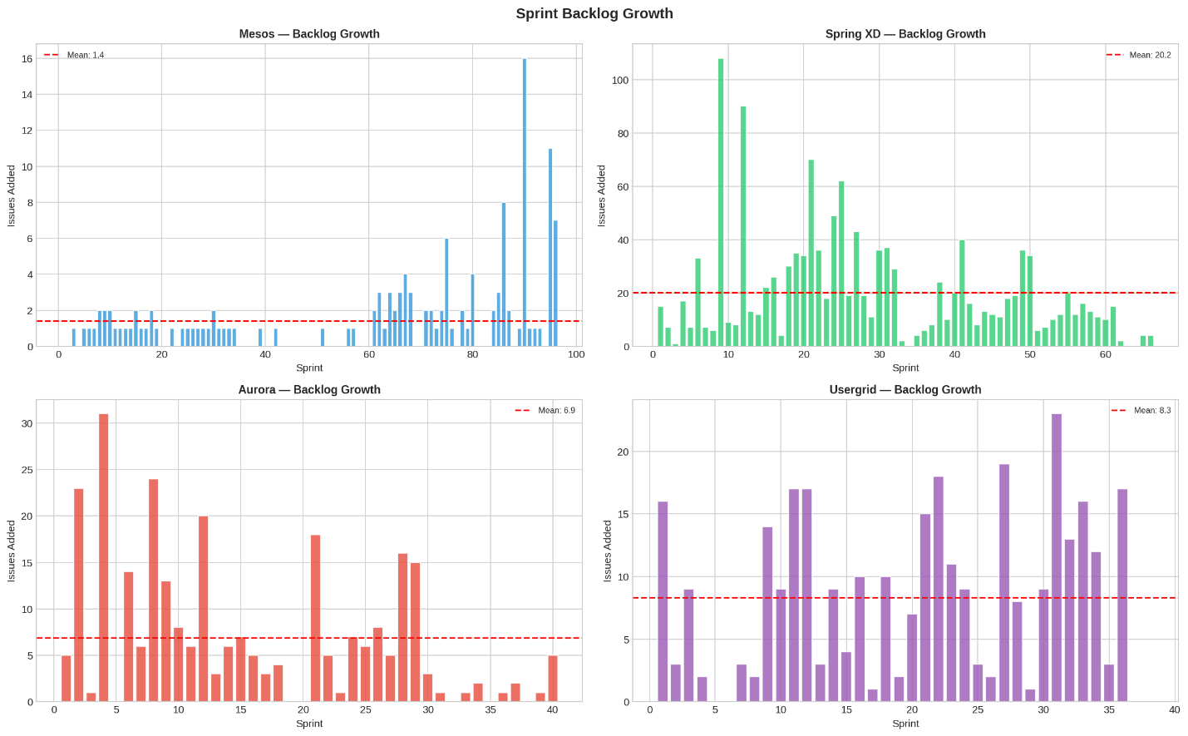

- Sprint Development Length – Box Plots
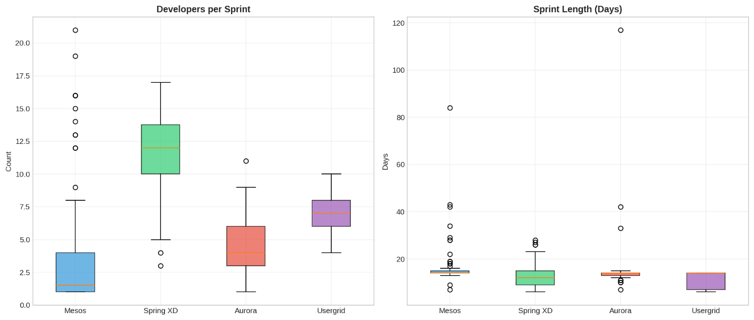
- Sprint Velocity Trends
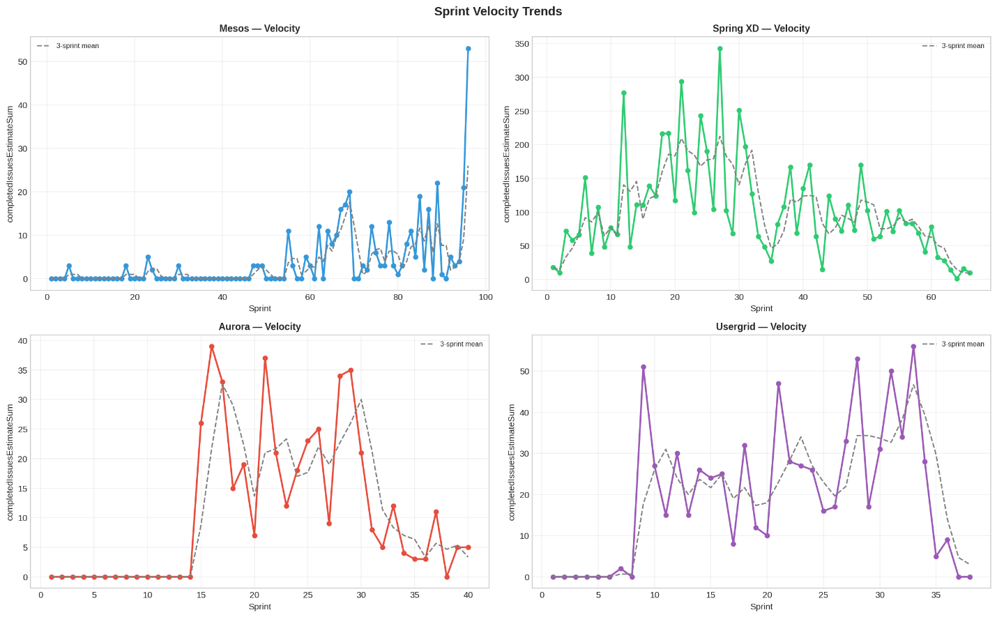

- Current Story Point Distribution
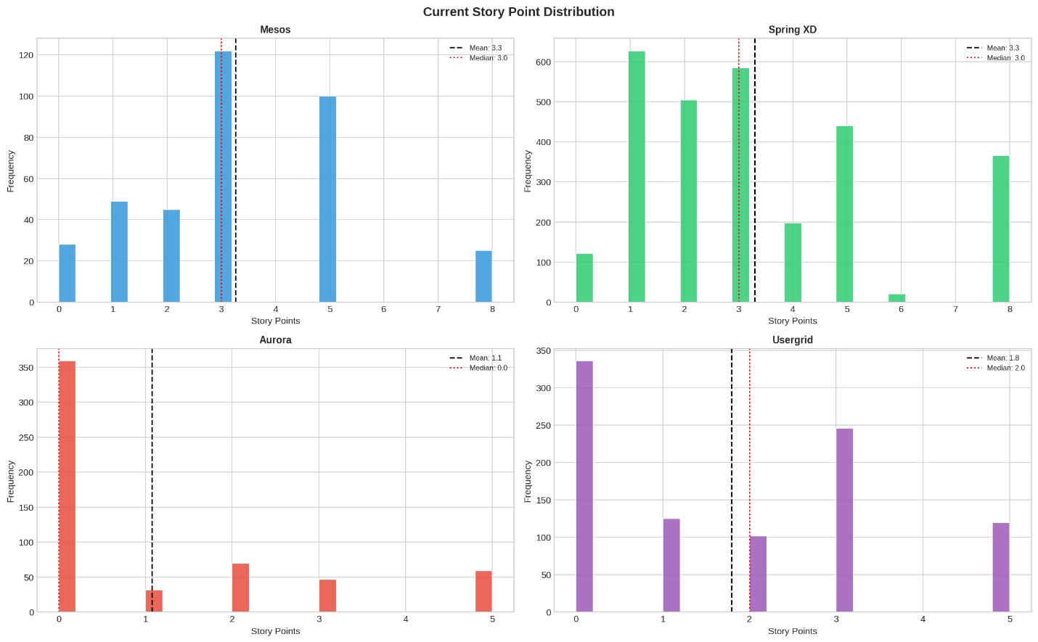

COPY OF PROJECT SPECIFICATION
MSc Masters Project Specification

Student’s Name: Manfred Oppong
Banner id: B01814357
MSc Programme (specify the specialist pathway, if any): MSc IT with Project Management
MSc Programme Leader:

Project Title (5 Marks)
The Role of Artificial Intelligence in Enhancing Predictive Risk Management in Agile IT Projects

Abstract
(Project overview reflecting the larger scope of the project.) (10 Marks)
The use of agile methodologies prevails in modern IT project delivery because of its flexibility, iterative nature, and changeability. In spite of these strengths, Agile IT projects are still characterized by schedule slippage, scope instability, cost overruns, and quality defects. Agile risk management is typically informal and reactive, based on sprint reviews, velocity measures, and team opinion instead of predictive mechanisms.
The recent developments in the sphere of Artificial Intelligence (AI) provide the possibility to improve the risk forecasting in the project environment. Prediction models based on machine learning, anomaly detection, and pattern recognition are examples of AI-driven analytics that can be used to analyze historical and real-time project data to determine early warning signs of potential risks. Even though AI-enabled functionality is becoming a part of Agile project management tools, the effectiveness of these features is not empirically tested.
The purpose of this project is to design, implement and evaluate a prototype AI-based predictive risk analysis system based on publicly available Agile project datasets. Machine learning will be utilized to develop the artefact and predict the possible project risks according to the sprint metrics like the velocity trends, defect density, backlog growth, and schedule variance.
Quantitative experimental research design will be used. Predictive models will be trained and tested using historical Agile datasets. Classification metrics like accuracy, precision, recall, F1-score, and ROC-AUC will be used to determine the performance of the prototype.
The project will deliver a practical predictive risk prototype and empirical assessment outcomes, which will provide the understanding of the efficiency of AI-based risk forecasting in Agile IT settings. The research will also offer practical implications of incorporating AI in Agile governance models.

Justification and overall Aim (10 Marks)
(Rationale for the research showing gaps in the current knowledge and general statements on intent and direction of the project*)
The prevailing method of software and IT development has shifted towards agile project management, which focuses on flexibility, teamwork, and incremental delivery (Schwaber and Sutherland, 2020). Nonetheless, industry reports indicate that a significant number of IT projects still fail to achieve time, cost, and scope targets (Standish Group, 2020). Among the challenges is the reactive aspect of risk management in Agile settings, where the risks are usually addressed when they start to interfere with the performance of the sprints.
Classical risk management models, including those provided in PMBOK (PMI, 2021), promote a systematic identification, qualitative and quantitative analysis of risks, and ongoing monitoring. These formalized methods may, however, come into conflict with the lightweight and rapid delivery cycles of Agile. As a result, lots of Agile teams are based on informal methods that do not have predictive depth.
Project analytics, such as effort estimation, defect prediction, and scheduling optimisation, have been progressively applied with the use of Artificial Intelligence (Marnewick, 2022; Wang et al., 2021). AI can detect non-linear and complex relationships in project data that is difficult to identify in manual analysis. Although this is possible, there is a lack of empirical studies that assess the role of AI in predictive risk management in Agile IT projects.
Moreover, most of the studies available are based on surveys or conceptual frameworks as opposed to quantifiable project performance data. Evidence-based analysis based on structured datasets to determine whether AI-based predictive analytics actually enhance risk detection and project performance is thus required.
This gap is filled in this project by performing systematic secondary data analysis of Agile project datasets and AI-generated performance indicators.
Overall Aim:
To determine the effectiveness of predictive methods that are driven by Artificial Intelligence in improving the results of risk management in Agile IT projects.

Objectives (10 Marks)
(List of tasks to be undertaken to achieve overall aim of the project* and to answer the research question posed)
To achieve the overall aim of the project, the following objectives will be pursued:
- To critically review the literature that is available on Agile risk management, predictive analytics, and machine learning applications in project settings.
- To locate, pre-process and format publicly available Agile project datasets in a way that they can be used in predictive modelling.
- To create and deploy a machine learning-based predictive risk model through the use of appropriate sprint and performance measures.
- To test the predictive capability of the constructed model with the help of established classification measures.
- To compare the AI-based predictive outputs to the conventional Agile performance tracking indicators.
- To obtain realistic suggestions on how to incorporate AI-based predictive risk systems in Agile IT project governance.

Review of Literature (20 Marks)
(An account of the current thinking/published information in the specific area of project*)
Agile practices like Scrum and Kanban have emerged as the prevailing trends in software and IT project delivery because of their focus on flexibility, collaboration, and incremental value delivery (Highsmith, 2019). Agile encourages responsive planning and feedback to stakeholders, which allows teams to effectively respond to evolving requirements and technological uncertainty. According to industry surveys, Agile methods are now widely used by software teams in one form or another, with over 70 percent of surveyed teams adopting Agile. But on the one hand, Agile enhances responsiveness and customer focus, on the other hand, it tends to minimize the focus on formal documentation and formal governance mechanisms.
One of the areas that have been greatly impacted by this change is risk management. Traditional project environments involve formal documentation of risks, analysis, prioritisation and monitoring of risks during the project lifecycle. Agile risk management, in turn, is often a part of sprint planning, backlog refinement, daily stand-ups, and retrospectives (Conforto et al., 2016). Agile teams do not have detailed risk registers but instead use transparency, communication, and reviewing to identify issues. Although this informal style is consistent with the Agile principles, it may restrict predictive ability since risks are often addressed when they start to impact the performance of sprints or delivery results.
The conventional project risk management models, like those described in the PMBOK Guide (PMI, 2021), focus on the systematic procedures such as risk identification, qualitative and quantitative analysis, response planning, and monitoring. These are systematic ways of predicting uncertainty prior to its derailing of project delivery. Probability-impact matrices and simulation models are quantitative tools that are typical of plan-driven environments. Nevertheless, critics say that they may be documentation-intensive and not as dynamic and fast-paced as Agile (PMI, 2021). Agile projects are carried out in a setting where requirements change at a very fast pace, which complicates long term predictive modelling. This poses a conflict between a formal risk management and Agile responsiveness.
Artificial Intelligence (AI) has become an innovative potential in project analytics and decision support. The development of machine learning and predictive modelling enables organisations to process large amounts of past and current project data. The AI methods have been used effectively in the prediction of software defects, schedule, and effort (Wang et al., 2021). To illustrate, machine learning models may be used to process historical data on sprints to enhance accuracy of forecasts as opposed to conventional estimation techniques. Classification algorithms have also been found to be useful in forecasting high-risk software components that are likely to defect.
The use of AI-based anomaly detection is especially applicable to Agile environments. Through constant monitoring of metrics like the pace of sprints, the rate of backlog growth, the deviation of the burn-down charts, and the rate of defects, AI systems can detect abnormal trends that can be indicative of the emergence of risks. These predictive signals give a warning before problems arise to cause serious schedule slippage or cost increase. In contrast to the traditional risk registers, AI-based systems can dynamically update predictions with new sprint data as it becomes available, which is more consistent with the iterative cycles of Agile.
The automation-augmentation controversy can provide an idea of the way AI is supposed to be incorporated into project management. Raisch and Krakowski (2021) suggest that AI can be most beneficial when it enhances human judgement and does not completely automate decisions. Contextual awareness, leadership, and teamwork are crucial in knowledge-intensive settings like IT project management. AI has the potential to enhance managerial performance by offering data-driven insights, although human interpretation is at the core. AI in Agile environments is thus better applied as a decision support tool that helps to increase risk awareness without disrupting collaborative practices.
Although there is a growing incorporation of AI capabilities in project management platforms, empirical assessment is still in pieces. A variety of business applications have predictive dashboards, automatic alerts, and performance forecasting. Nevertheless, much of the scholarly work is concerned with the accuracy of the algorithms and not its impact on the organisation. Little quantitative data has been conducted to investigate whether AI-generated predictive indicators are related to quantifiable project results, including better delivery predictability, decreased variance of planned velocity, or defect rates.
In addition, the literature tends to look at individual technical uses of AI, like prediction accuracy of defects, without evaluating the impact of AI knowledge on managerial decisions or governance. Factors of organisational adoption, trust by practitioners in AI outputs, and compatibility with Agile workflows are under-researched. With the growing pace of digital transformation, the role of AI in improving project governance is becoming a more relevant topic of both theoretical and practical significance.
This project fills these gaps by undertaking systematic secondary data analysis of Agile project data with particular emphasis on predictive risk management results. The analysis is based on quantifiable performance metrics, like schedule compliance, sprint velocity consistency, and defect patterns, which is why the research is no longer a conceptual discussion and algorithm experimentation. It assesses the predictive signals that are enabled by AI against observable project performance improvements.
By doing this, the research will add to the body of Agile project management and the current research on AI-driven decision support. It reinforces the empirical knowledge of the potential of predictive analytics to supplement Agile practices and evidence whether AI is of relevance to risk anticipation or merely creates more metrics. Finally, the study guides more evidence-based strategies of digital project governance within Agile settings.

Methodology (25 Marks)
(Explanation and justification of approach and methodology proposed for the project*. This section should explain the nature of the data and method of data collection. Identification and brief discussion of any analytical tools to be used; Identification of any ethical and practical issues.)
Research Design

The research design of this study is a quantitative experimental research design that focuses on artefact development and performance evaluation. The objective is to design, train and test a predictive model that can detect emerging risk trends in Agile project settings. The quantitative approach is suitable since the study aims to investigate quantifiable correlations between Agile performance metrics and predictive risk indicators based on machine learning approaches (Wang et al., 2021). The use of structured numerical data instead of perceptual responses increases objectivity, replicability, and statistical reliability of the study.
The experimental part will be the training and validation of predictive algorithms based on historical Agile project data. This design corresponds to the current literature on AI-based decision-support systems, in which the artefact construction and empirical validation are the main focus of proving practical and organisational value (Raisch and Krakowski, 2021). Instead of providing a conceptual discussion, the study assesses the predictive performance in terms of measurable outputs.

Data Sources

The study uses only secondary data based on the publicly available Agile project repositories. There are no human subjects. Open-source issue tracking systems like GitHub will be used to obtain data, which will include detailed project histories, including commits, issue logs, defect reports, sprint metadata, and backlog changes. Such repositories provide deep longitudinal data that can be used in predictive modelling.
Moreover, there will be the use of sprint performance data stored in software engineering research archives. Examples of such datasets are structured measures like sprint velocity, defect density, backlog growth rates, issue resolution time and delivery variance. Past empirical studies have used historical Agile project metrics which will also be used where available.
External validity and generalisability are improved by using multiple datasets. Velocity charts and backlog metrics are examples of agile artefacts commonly used to indicate the stability of delivery and emerging risk (Conforto et al., 2016). The study empowers empirical relevance by basing the analysis on real project behaviour as opposed to simulated environments.

Data Pre-processing

Strict preprocessing will be done to guarantee the quality and consistency of data. Raw project data is often incomplete, inconsistent and noisy. Preliminary cleaning shall thus entail the removal of duplicates, format errors and filtering irrelevant variables. Numerical variables will be normalised so that they can be compared across features and to enhance the performance of algorithms.

The key aspect of predictive modelling is feature selection. According to the existing studies in the field of software analytics (Wang et al., 2021), the candidate predictors are the trends in sprint velocity, defect density, backlog growth, issue resolution time, and planned delivery variance. These variables are measurable proxies of emerging delivery risk. The most influential predictors will be determined using correlation analysis and feature importance techniques.

The missing values will be dealt with by using the right strategies like mean or median imputation, or by deleting the incomplete records where required. The overall dataset will be split into training and testing subsets, typically with an 80/20 split. This will ensure that the model performance is tested on unknown data, which minimises overfitting and enhances generalisability.

Model Development

Python will be used to create the predictive artefact based on the existing machine learning libraries like scikit-learn. Various classification algorithms will be used and compared to determine the best predictive method.

The Logistic Regression will be used as a baseline model since it is easy to interpret and can be used in binary classification. Random Forest algorithms will be considered due to their strength and capacity to model nonlinear relationships. Gradient Boosting techniques will also be experimented, since they tend to give good predictive accuracy in structured data. Support Vector Machines (SVM) can be used when the dimensionality of features needs to be classified using margin-based methods.

The comparison of the predictive performance based on the evaluation metrics will be used to select the model. Hyperparameter tuning will be done in a systematic way. The cross-validation will be employed to guarantee the robustness and stability of cross-validation across a variety of data folds, which will minimize the threat of the performance bias related to a single train-test split. This enhances internal validity and makes sure that the final model works uniformly in response to changes in the dataset.

Artefact Implementation

The artefact created will be comprised of three combined elements: a trained predictive model, a testing pipeline, and a visualisation layer. The trained model will produce probability scores that will reflect the probability of the occurrence of risk conditions. The testing pipeline will be automated to preprocess, extract features and predict on new datasets and be reproducible.

The risk probabilities will be displayed in a format that can be interpreted, e.g., probability thresholds or risk dashboards. Consistent with the augmentation perspective (Raisch and Krakowski, 2021), the artefact is meant to aid managerial judgement and not substitute it. Agile governance involves clear visual outputs, which are more interpretable and practical to use.

Model Evaluation

Standard classification metrics will be used to determine model performance. Correctness will be measured as overall predictive correctness. Precision will assess the percentage of the high-risk cases that are actually risky, minimizing false positives. Recall will evaluate how the model can identify the real cases of risks, reducing false negatives. The F1-score will give a balanced score of the precision and recall.

Receiver Operating Characteristic - Area Under the Curve (ROC-AUC) will also be calculated to determine the discriminatory power of the model at the classification thresholds. ROC-AUC is especially applicable when there is an imbalance in the classes, where extreme risk events tend to be less common in project data.

The study guarantees methodological transparency and analytical rigour through systematic comparison of algorithms and sound evaluation procedures.

Ethical Considerations

Data used in the study are publicly available and anonymised. No sensitive or personal information will be gathered. The risk of ethics is low, and no formal ethical approval is needed.

Work Plan (10 Marks)
(A timetable for completion of the project*. MSc Masters Project full-time is allowed 15 weeks and part-time is 30 weeks. You may use any appropriate method to present the well-thought-through plan of action reflecting your project* activities)
- Weeks 1–2: Finalisation of scope and dataset identification
- Weeks 3–5: Literature review
- Weeks 6–7: Dataset pre-processing
- Weeks 8–10: Model development
- Weeks 11–12: Model testing and evaluation
- Weeks 13–14: Writing and refinement
- Week 15: Final submission

References
(Correctly presented in Cite Them Right Harvard style) (10 Marks)
Conforto, E.C., Salum, F., Amaral, D.C., da Silva, S.L. and de Almeida, L.F.M. (2016) ‘Can Agile project management be adopted by industries other than software development?’, Project Management Journal, 47(3), pp. 21–34. https://doi.org/10.1002/pmj.21558

Highsmith, J. (2019) Agile Project Management: Creating Innovative Products. 2nd edn. Boston: Addison-Wesley.

Marnewick, C. (2022) ‘Artificial intelligence in project management: the way forward’, International Journal of Project Management, 40(4), pp. 373–386.

PMI (2021) A Guide to the Project Management Body of Knowledge (PMBOK® Guide). 7th edn. Newtown Square, PA: Project Management Institute.

Raisch, S. and Krakowski, S. (2021) ‘Artificial intelligence and management: The automation–augmentation paradox’, Academy of Management Review, 46(1), pp. 192–210. https://doi.org/10.5465/amr.2018.0072

Saunders, M., Lewis, P. and Thornhill, A. (2019) Research Methods for Business Students. 8th edn. Harlow: Pearson.

Schwaber, K. and Sutherland, J. (2020) The Scrum Guide. Available at: https://scrumguides.org

Standish Group (2020) CHAOS Report 2020. Boston: Standish Group.

Wang, G., Li, Y., Wang, T. and Chen, H. (2021) ‘Machine learning approaches for software effort estimation and defect prediction: A systematic review’, Information and Software Technology, 137, 106588. https://doi.org/10.1016/j.infsof.2021.106588

Wang, X., Conboy, K. and Cawley, O. (2021) ‘Leverage digital analytics for Agile project risk management’, Journal of Systems and Software, 176, 110939.

Marking scheme
(Marking scheme for final report/dissertation. Note: For group project, each student in a team must submit their own sections for- Presentation of results, Conclusions and Critical Self-Evaluation)

Introduction | 5
Literature Review | 15
Research Design | 15
Implementation | 25
Testing | 10
Presentation of Results | 10
Conclusions | 10
Critical Self-Evaluation | 10
Total | 100

Supervisor

Moderator

Programme Leader

Date specification submitted

Please complete the ‘ethics’ & pathway confirmation form below for all projects.
School of Computing, Engineering and Physical Sciences

MSc Masters PROJECT – REQUIREMENT FOR ETHICAL APPROVAL & PATHWAY CONFIRMATION

SECTION 1: TO BE COMPLETED BY THE STUDENT(S)
Does your proposed research involve: research with human subjects (including requirements gathering and product/software testing), access to company documents/records, questionnaires, surveys, focus groups and/or other interview techniques? Does your research entail any process which requires ethical approval? (please enter √ in the appropriate box)

YES |  | You must submit an application for approval to the Ethics Review Manager
NO |  | You do not need to submit an application to the Ethics Review Manager

I confirm that the above project specification aligns with my MSc programme specialist pathway. (please enter √ in the box)

Name of student (print name): Manfred Oppong

Signature: M. O

SECTION 2: TO BE COMPLETED BY THE PROJECT SUPERVISOR
I understand that the above project requires/does not require* ethical approval (*please delete as appropriate).
√ I confirm that the above project aligns with the MSc programme specialist pathway the
Student(s) is (are) enrolled in. (please enter √ in the box)

Supervisor (print name): Durfashan Tariq

Signature: Durfashan

Date:23/02/2026

IMPORTANT: please note that by signing this form all signatories are confirming that any potential ethical issues have been considered and, where necessary, an application for ethical approval has been/will be made via the Ethical Review Manager software.
Any project requiring ethical approval but which has not been given approval will not be accepted for marking.
Ethical approval cannot be sought in retrospect.

COPY OF PROJECT SPECIFICATION
Student(s): Manfred Oppong
Supervisor: Durfashan Tariq (Associate Lecturer, School of Computing, Engineering and Physical Sciences, University of West of Scotland)
Meeting Number: Latest supervision / draft feedback meeting (number not specified; refers to the most recent discussion and follow-up emails)
Date/Time: Last Friday meeting (notes provided) + email feedback on 22 April 2026 (timestamps: 15:18–15:34 for draft & self-reflection feedback; 20:50–20:53 for dataset guidance)
Agenda for meeting: (Agenda not clearly stated in advance; deduced as per the notes and context as: overview of submitted draft specification, chapter-by-chapter feedback, critical self-reflection check, general dissertation structure and word-count updates, implementation emphasis, and troubleshooting of problems accessing/extracting data on the fly).
Discussion of agenda items:
- Chapter 4 feedback (draft email + meeting notes): Incorporate tangible information to make it reproducible. Be more critical in justifying technical options. Insert graphs/tables, images/pictorials of work. Re-read and specify the Aim. When updating the appendix, give sources of data easy names so that they can be easily identified.
- Chapter 5 feedback: Include a more critical assessment of results. Add in a mention of whether differences between models are statistically significant (even temporarily) and comment on uncertainty in your measures.
- Chapter 6 feedback: Minimize statements about practical impact unless backed by data. Differentiate better between contributions that are really novel by making direct comparisons with particular previous studies. Include a brief discussion of ethical or organisational risks (e.g., over-reliance on predictions, proxy label bias). Make your future work section a priority to demonstrate what to do and why to do it first.
- Critical self-reflection: Supervisor could not locate this part in the submission.
- Overall dissertation guidance (meeting notes): Supervisor was unable to find this section in the submission. Abstract should not be more than 200 words. Implementation section is quite significant. There should be a conclusion as to what has been accomplished. Take references with great care. Attach a copy of final specification with references and appendix. Include reference to your artefact in the dissertation. Check on AI phrasing- work ought to sound more human. The entire dissertation has been trimmed down to 7,500 words (quality, not quantity; no fluff or superfluous words)..
- Dataset access issues (follow-up emails): Student claimed that she had difficulties accessing the ZIP file. Supervisor agreed that it is challenging but stressed that the data preparation/validation should be finished long before the 23rd deadline. Included detailed step-by-step instructions of extraction and recommended continuing with any portion of the data available and properly documented limitations in the methodology and discussion chapters.
Summary of agreed action plan:
- Immediate revision of Chapters 4, 5, and 6 based on the above specific feedback (add reproducibility information, critical analysis, statistical/uncertainty discussion, novelty comparisons, ethical risks, and future work priorities).
- Add the missing critical self-reflection section.
- Extract with either 7-Zip or WinRAR (extract to a basic directory, verify folder structure, merge files as necessary) or whatever data is available and record all restrictions.
- Revise Abstract (200 words or less), reinforce Implementation, revise Conclusion to reflect successes, revisit all references, and add final specification, artefact link.
- Make sure that your whole dissertation does not exceed 7,500 words and focus on quality and human-sounding writing.
- Regularly update Appendix and identify data.
Notes:
- Ethical approval: Project does not need ethics review (NO box on 23/02/2026 signed by both student and supervisor).
- Emphasis throughout: Quality not quantity - no long/unnecessary reports.
- Appendix can be updated on a regular basis and will contain this process documentation template as well as the final project specification.
- All future work prioritisation and ethical/organisational risk discussions should be supported as much as possible.
- Select what you have over an unlimited troubleshooting; write down all that is clear.

